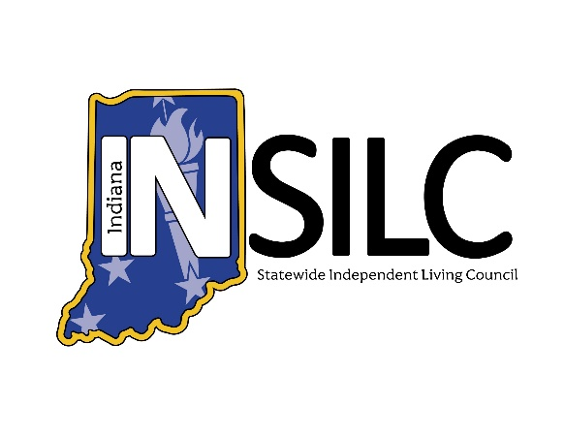

INSILC Public Meeting Minutes
September 9, 2026

Meeting Information:
Date: Wednesday, September 9, 2026
Set Up/Accessibility Checks: 1:45 – 2:00 PM ET
Meeting Time: 2:00 – 4:00 PM ET
Meeting Type: Public, Hybrid
Description: INSILC Council Public Meeting. Open to the Public.
In-Person Location: Easterseals Crossroads
4740 Kingsway Dr. Indianapolis, IN 46205
Platform: Zoom and In-Person
Zoom Webinar Link
Join via audio: +1 312 626 6799 US

To access a live transcript of the meeting, visit the link or scan the code:
Live Captioning Link

INSILC Public Council Meeting Minutes:

Call to Order & Welcome – Kacie Weldy, Chair

Roll Call – Kacie Weldy, Chair
- Voting Members:
- Kacie Weldy, Chair - Present
- Luis Roman, Vice-Chair – Absent (excused)
- Anna Thompson-Jones, Treasurer - Present
- Jennifer David, Secretary - Present
- Amy Browning-Varble, CIL Director Representative - Present
- Ann Barnhart, Council Member - Present
- Halie Brown, Council Member - Absent
- Linda Greeno, Council Member – Present (Late)
- Laura Kitterman, Council Member - Absent
- Gary Olsen, Council Member - Absent
- Christina Trimnell, Council Member - Present
- Catherine Vest, Council Member – Absent (excused)
- Dave Schleppenbach, Council Member – Present
- Danielle Bradley, Council Member - Present

- Non-Voting Members:
- Amy Luellen, FSSA, Designated State Entity Representative - Present

- Guest Attendees
- Mike Foddrill, INSILC Executive Director - Present
- Katy Myers, INSILC Operations Manager – Absent (excused)
- State Plan Committee Chair (Vacant)

Statement of Accessibility & Means for Resolution of Access Concerns – Mike Foddrill, Executive Director
Contact INSILC Executive Director Mike Foddrill with any access concerns.
Email: MFoddrill@indianasilc.org
Phone: 317-514-6145

Confirmation of Quorum – Jennifer David, Secretary
Total No. of appointed Council Members: 15
No. Council Members Present: 10
No. Voting Members Present: 9
Percentage of Voting Members: 66.7%
Has meeting attained Quorum: Yes

Approval of Minutes – Kacie Weldy, Chair
June 10, 2026 Public Meeting Minutes*
July 22, 2026 Special Session Public Meeting Minutes*
-Motion to approve both minutes: Jennifer David
-Seconded by: Danielle Bradley
-Approved unanimously

Ongoing Communications – Jennifer David, Secretary

Upcoming Public Meetings
      - Meeting Day: Wednesday
      - Meeting Time: 2:00 – 4:00 PM ET
      - Upcoming Dates:
- December 9, 2026
- March 10, 2027
- June 9, 2027
- September 8, 2027
- December 8, 2027

Notice of Communication Rules for Public INSILC Meetings:
    - Announcement of the speaker’s time limit.
    - Meeting facilitator
      - Will state when the time limit has ended
      - Will then mute the speaker.
    - Additional comments not received in the meeting can be received via other methods, which can be found at this link: https://insilc.org/feedback/
    - View INSILC's policy on Public Participation and Comment in Public Meetings on page 12 of the Public Facing Policies Document located at the bottom of the About page on the INSILC website.
    - Please identify oneself before speaking and speak at a steady speed for interpreting accessibility.

Public Comment – Open for 15 Minutes

Committee & State Updates, Reports, Comments
  - Executive Director Report – Mike Foddrill
  - Treasurer Report – Anna Thompson Jones
  - CIL Director Representative Report – Amy Browning-Varble
  - Designated State Entity Report – Amy Luellen
  - State Plan Committee Report – Ann Barnhart
  - Marketing & Engagement Committee Report – Dee Ann Hart
  - Nominations Committee Report – Mike Foddrill

Old Business
  - State Plan/Corrective Action Plan Status – Mike Foddrill
  - Strategic Planning Discussion – Mike Foddrill
  - Hoosier Deaf/Blind Alliance Project – Kacie Weldy
  - Credit Card Update – Mike Foddrill

New Business
  - FY27 Budget* – Anna Thompson Jones
-Motion by: Dave Schleppenbach
-Seconded by: Jennifer David
-Approved unanimously
  - Slate of New Council Members* – Mike Foddrill
-Motion by: Jennifer David
-Seconded by: Anna Thompson Jones
-Approved unanimously
  - Strategic Plan Language* – Mike Foddrill
-Motion by: Jennifer David
-Seconded by: Danielle Bradley
-Approved unanimously
  - Attendance Policy – Kacie Weldy
  - Engagement Activities Report – Mike Foddrill
    - INSILC.org/engagement-activities-report/

Public Comment – Opened for 15 Minutes

Adjournment
-Motion by: Amy Browning-Varble
-Seconded by: Anna Thompson Jones
-No vote needed

Accommodation Requests
INSILC provides ASL interpreting and CART services at all public meetings and events. To request an additional accommodation, email info@indianasilc.org.
Please make requests at least two business days in advance to help ensure the availability of the accommodation.

Glossary of Abbreviations:
INSILC – Indiana Statewide Independent Living Council
ASL – American Sign Language
CIL – Centers for Independent Living
DSE – Designated State Entity
FSSA – Family Social Services Agency
SPIL – Statewide Plan for Independent Living
FY – Fiscal Year

