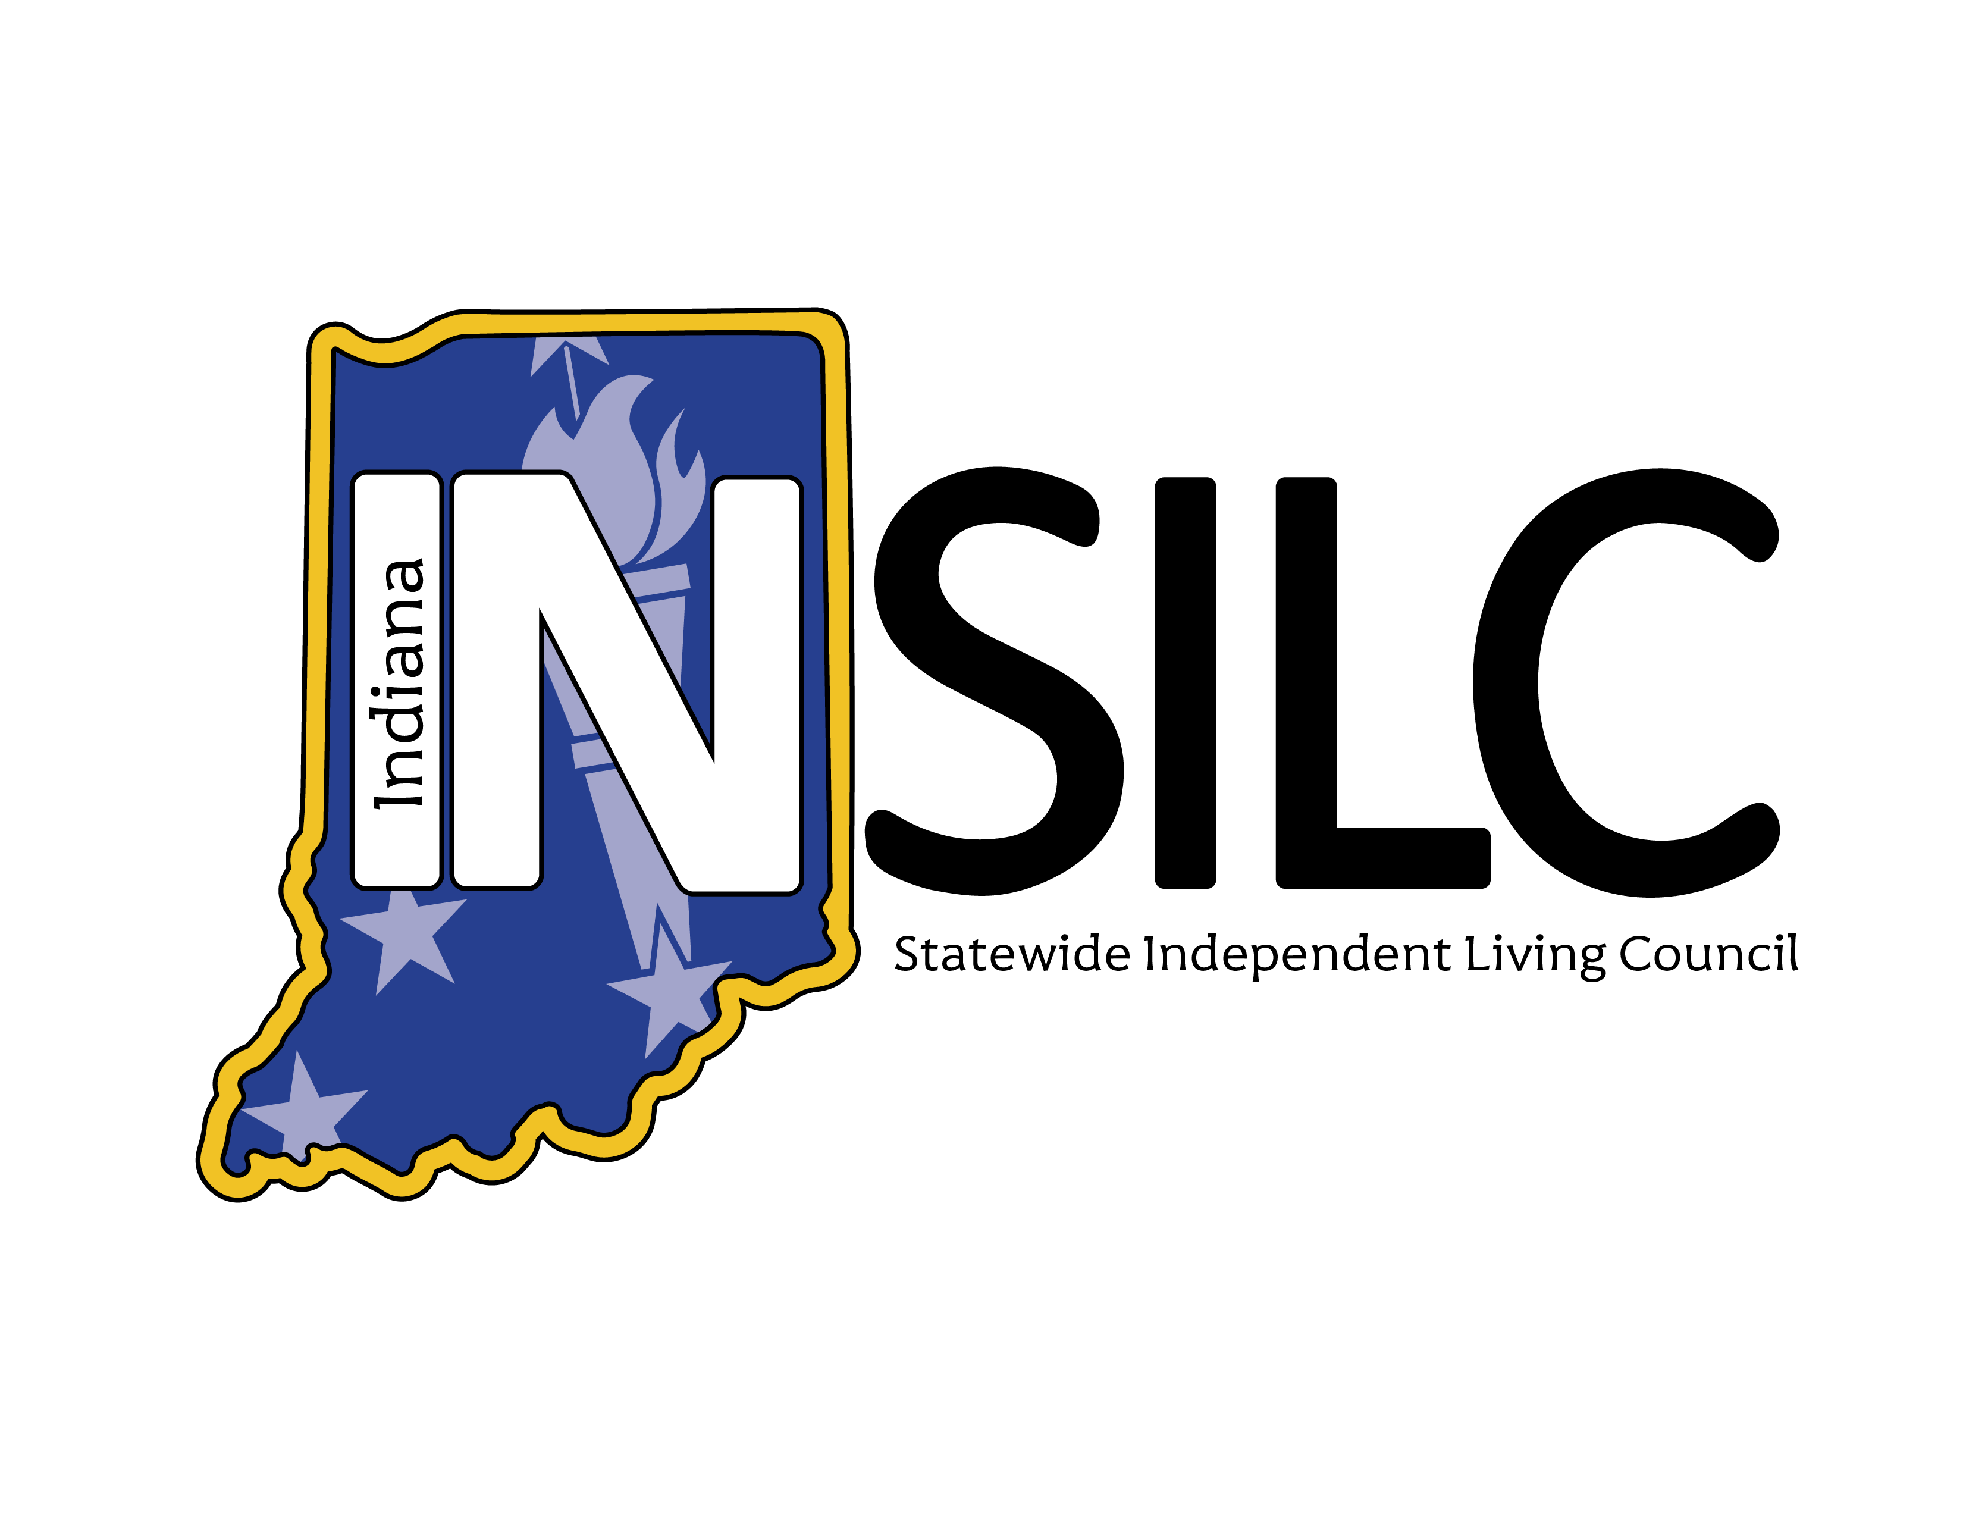

2025-2027 State Plan for Independent Living (State Plan) Dashboard Report
Data from October 1, 2025-June 30, 2026
The following provides a snapshot of progress on the 2025–2027 State Plan for Independent Living, made collectively Indiana’s Independent Living Network.
Please send questions or accommodation requests to Info@IndianaSILC.org.
State Plan goals are set up in the following sequence: Goal > Objective > Indicator > Outcome. Please refer to the full State Plan (linked above) to read the details. This dashboard tracks the progress of the indicators of the plan by assigning each indicator a status on the following scale:
- Exceeded—a target was exceeded.
- Met—the target was met exactly.
- Substantially Met—greater than 60% and less than 100% was achieved.
- Partially Met—greater than 0 but less than 60% was achieved.
- Not Met—nothing was achieved.
- No Progress—the target was delayed or not started.
For indicators rated partially met, not met, or showing no progress, an update will be provided for how progress will be achieved. For details on each indicator, please refer to the 2025 Annual Report linked here.

2026 State Plan Dashboard Publishing Schedule
Friday, May 8 | Y2 Q1 & Q2 Dashboard Published
Friday, August 7 – Posted August 16 | Y2 Q3 Dashboard Published
Friday, November 6 | Y2 Q4 Dashboard Published

State Plan Goal Progress – Year 2 Compiled Data
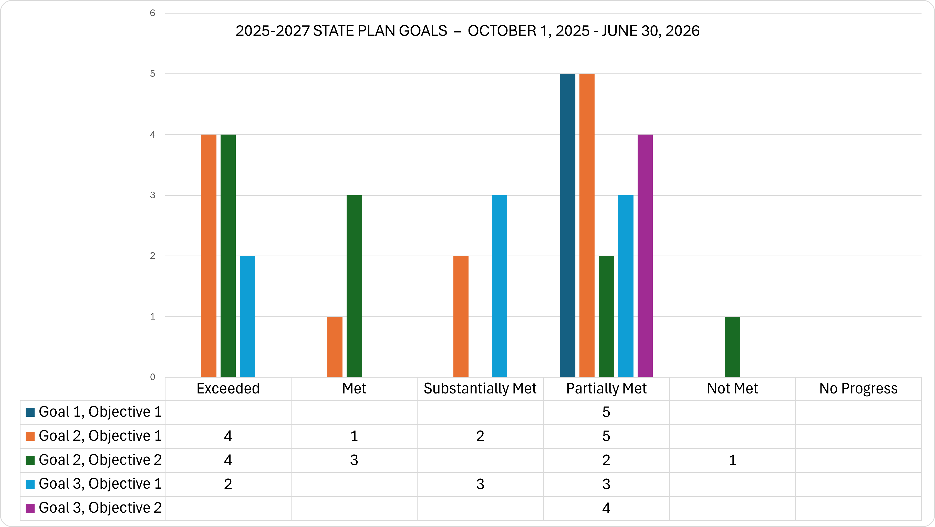
Image Description: Clustered bar chart titled “2025-2027 State Plan Goals – October 1, 2025 to June 30, 2026.” The chart shows progress status that counts for five objectives across six categories: Exceeded, Met, Substantially Met, Partially Met, Not Met, and No Progress.
- Goal 1, Objective 1: 5 Partially Met
- Goal 2, Objective 1: 4 Exceeded, 1 Met, 2 Substantially Met, and 5 Partially Met
- Goal 2, Objective 2: 4 Exceeded, 3 Met, 2 Partially Met, and 1 Not Met
- Goal 3, Objective 1: 2 Exceeded, 3 Substantially Met, and 3 Partially Met
- Goal 3, Objective 2: 4 Partially Met
Overall, Partially Met is the most common status, with the highest value being 7 for Goal 2, Objective 1. No objectives are reported under No Progress.
Of the 39 indicators in Year 2, 35.90% are exceeded or met, 61.54% are substantially met or partially met, and 2.56% are not met.

Indicator Detail
Click here to find full indicator language, starting on page six of the State Plan.

Goal 1: Strengthen the Indiana Independent Living Network (the Network) and increase resource capacity

Objective 1: Secure additional funding to support and expand the Network
Indicator Status | Count | Percent
Partially Met | 5 | 100%

Goal 1 Objective 1 Indicator Remediation Plans:
- 1.1.1 Other Funding report shows a 2% increase
  - Partially Met: The Network raised over $600,000 in Q3, however the combined total for Year 2 has not reached a 2% increase over Year 1. Each Network member will continue to pursue funding to the best of their ability.
- 1.1.2 Service report shows a 2% increase
  - Partially Met: Centers for Independent Living (Centers) provided nearly 6,000 services to consumers in Q3, however the total for Year 2 has not reached a 2% increase over Year 1. The Centers will continue to provide as many services as staff capacity allows.
- 1.1.3 Community activities report shows a 2% increase
  - Partially Met: The Network spent over 600 hours on community activities in Q3, however the total for Year 2 has not reached a 2% increase over Year 1. Each Network member will continue to seek out and record as many community activities as staff capacity allows.
- 1.1.4 Community activities related to systems advocacy show a 2% increase
  - The Network spent over 150 hours on systems advocacy activities, but the total for Year 2 has not reached a 2% increase over Year 1. Each Network member will continue to seek out and record as many community activities as staff capacity allows.
- 1.1.7 Distribute Resource Capacity Assessment; Facilitation of activities that promote increased resources
  - INSILC will distribute the Year 2 Resource Capacity Assessment by August 31, 2026. INSILC and the Centers will explore a shared system where potential funding sources can be catalogued and pursued collaboratively. A list of participating Centers will be finalized by the end of October 2026.

Goal 2: Increase community capacity to support the Independent Living Network and promote the Independent Living Philosophy statewide

Objective 1: Educate the community on issues impacting people with disabilities to increase awareness and improve outcomes
Indicator Status | Count | Percent
Exceeded | 4 | 33.33%
Met or Substantially Met | 3 | 25%
Partially Met | 5 | 41.67%

Goal 2 Objective 1 Indicator Remediation Plans:
- 2.1.3 / 2.1.11 INSILC will contribute/lead one (1) Network conference for cross-disability networking opportunities during the State Plan period
  - INSILC and seven Centers are actively planning a conference to be held September 29-30, 2026. While not all Centers are involved in the planning, all Center leadership and staff, people with disabilities, and other members of the public are encouraged to attend.
- 2.1.4 / 2.1.8 Consumer Needs Assessment survey will be collected from people with disabilities seeking input of challenges and distributed
  - In Year 1, INSILC decided to rely on existing, external quantitative consumer needs and demographic data and instead pursue qualitative consumer needs data by hosting focus groups for the four target groups of this State Plan: veterans, racial and ethnic minorities, youth, and rural residents. Focus groups are currently underway; the compiled data report is expected to be available by the end of October 2026.
- 2.1.5 Employee reports show a 5% increase in the number of people with disabilities in leadership positions and in employment across the Network
  - While some Centers have been able to hire and promote people with disabilities, the total does not reach a 5% increase over Year 1. Centers will continue to hire and promote as funding allows.

Objective 2: Gather input from people with disabilities and strengthen peer-to-peer mentorship to elevate their voices statewide
Indicator Status | Count | Percent
Exceeded or Met | 7 | 70%
Partially Met | 2 | 20%
Not Met | 1 | 10%

Goal 2 Objective 2 Indicator Remediation Plans:
- 2.2.2 Plain language and Accessible format versions of the State Plan for Independent Living created and distributed
  - From late 2025 through spring 2026, INSILC requested proposals for and signed a contract with experts to create a plain language State Plan. Based on budget and timing, INSILC decided to focus the experts on the creation of a plain language 2030-2027 State Plan, which will be published alongside the technical version in the summer of 2030. This means that this indicator will not be met.
- 2.2.6 Consumer Needs Assessment survey will be collected from people with disabilities seeking input of challenges and distributed
  - In Year 1, INSILC decided to rely on existing, external quantitative consumer needs and demographic data and instead pursue qualitative consumer needs data by hosting focus groups for the four target groups of this State Plan: veterans, racial and ethnic minorities, youth, and rural residents. Focus groups are currently underway; the compiled data report is expected to be available by the end of October 2026.
- 2.2.7 Baseline data from inputs analyzed and identification of disability-centric organizations to establish collaborative partnerships
  - In Q3, INSILC joined a collaborative partnership of disability-centric organizations to form the Indiana Disability Alliance, which focuses on the protection of home and community-based services and prevention of unnecessary institutionalization of people with disabilities. This topic has been clearly identified as urgent and profoundly important to people with disabilities and their families. This indicator is partially met because this partnership primarily addresses one issue. INSILC and the Centers will continue to create opportunities for collaboration with other disability-centric organizations.

Goal 3: Promote and advocate for full inclusion of people with disabilities in all aspects of community life

Objective 1: Collaborate across the Independent Living Network to reduce barriers and increase awareness of Independent Living Philosophy and the role of Centers for Independent Living
Indicator Status | Count | Percent
Exceeded | 2 | 25%
Substantially Met | 3 | 37.5%
Partially Met | 3 | 37.5%

Goal 3 Objective 1 Indicator Remediation Plans
- 3.1.4 Collection of Network surveys, event surveys, and public input sessions to identify focus areas for collaborative efforts.
  - INSILC has been and will continue to compile input data from multiple Network sources, which will be reviewed by the State Plan Committee over the next eight months. Focus areas for collaboration include home and community-based services, transportation, employment, and Network outreach efforts. In addition to the work Network members are doing in these focus areas, the Network will formalize action plans for these areas in the 2027-2030 State Plan.
- 3.1.5 Baseline data from inputs analyzed and identification of disability-centric organizations to establish collaborative partnerships
  - In Q3, INSILC joined a collaborative partnership of disability-centric organizations to form the Indiana Disability Alliance, which focuses on the protection of home and community-based services and prevention of unnecessary institutionalization of people with disabilities. This topic has clearly been identified as urgent and profoundly important to people with disabilities and their families. This indicator is partially met because this partnership primarily addresses one issue. INSILC and the Centers will continue to create opportunities for collaboration with other disability-centric organizations.
- 3.1.8 INSILC will formulate a strategic plan for collaborative activities with disability-centric organizations and distribute within the Network
  - While INSILC has successfully collaborated with disability-centric organizations through its town hall events and membership in the Indiana Disability Alliance, INSILC has also begun working with experts to create a strategic plan that will set goals independent of the State Plan as well as provide tools and materials related to marketing, advocacy, and fundraising. This work will create a framework that will help INSILC increase effectiveness beyond one State Plan period. Details of the strategic plan will be shared at upcoming Council meetings, and the final plan will be available by early 2027.

Objective 2: Model strategic, cross disability systems change through responsive, innovative practices
Indicator Status | Count | Percent
Partially Met | 4 | 100%

Goal 3 Objective 2 Indicator Remediation Plans:
- 3.2.2 Consumer Needs Assessment survey will be collected from people with disabilities seeking input of challenges and distributed
  - In Year 1, INSILC decided to rely on existing, external quantitative consumer needs and demographic data and instead pursue qualitative consumer needs data by hosting focus groups for the four target groups of this State Plan: veterans, racial and ethnic minorities, youth, and rural residents. Focus groups are currently underway; the compiled data report is expected to be available by the end of October 2026.
- 3.2.3 INSILC shall provide information to Indiana's critical entities regarding Emergency Preparedness needs for people with disabilities
  - The Emergency Preparedness Workgroup has been compiling best practices for helping people with disabilities in emergencies and the list of contacts to receive the materials. A draft of the materials and distribution list is expected to be available by early 2027.
- 3.2.4 The Network will collaborate with disability-centric organizations to create materials to assist healthcare practitioners to create inclusive access and distribute the materials to over 80 counties.
  - The Healthcare Workgroup has begun drafting information and resources organized by category and will soon begin compiling a distribution list for the final resource guide. A draft of the materials and distribution list is expected to be available by early 2027.
- 3.2.6 One hundred people with disabilities have successfully completed the program
  - INSILC has partnered with The League’s Inclusion Institute to promote individuals with disabilities to complete the self-advocacy program. In Q3, 25 individuals graduated from the Inclusion Institute. More individuals are expected to enroll by the end of 2026.

