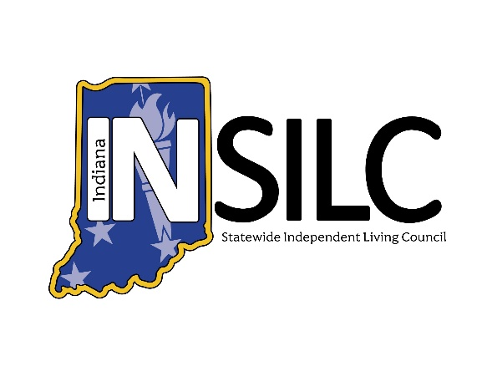

INSILC Public Meeting Minutes
June 10, 2026

Meeting information:
Date: Wednesday – June 10, 2026
Set Up/Accessibility Checks: 1:45 p.m. – 2:00 p.m. EDT
Meeting Time: 2:00 p.m. – 4:00 p.m. EDT
Meeting Type: Public Hybrid Webinar
Description: INSILC June Public Meeting. Open to the Public.
In-Person Location: Easter Seals Crossroads
4740 Kingsway Dr. Indianapolis, IN 46205
Platform: Zoom and in Person
Join from a PC, Mac, iPad, iPhone or Android device:
https://zoom.us/j/95724102735?pwd=Jjhrsy4cXxJ5MS7ZuYaSZSvgsRSi5X.1
Or One tap mobile:
+13126266799, 98910248145# US (Chicago)

INSILC Public Meeting Agenda:

Call to Order/Open Meeting & Welcome – INSILC Chair, Kacie Weldy

Roll Call – INSILC Chair, Kacie Weldy
- Voting Members:
- Kacie Weldy, Chair - Present
- Luis Roman, Vice-Chair - Present
- Anna Thompson-Jones, Treasurer - Present
- Jennifer David, Secretary - Present
- Amy Browning-Varble, CIL Director Representative - Present
- Ann Barnhart, Council Member - Present
- Halie Brown, Council Member - Present
- Linda Greeno, Council Member - Present
- Laura Kitterman, Council Member - Not Present
- Gary Olsen, Council Member – Not Present
- Christina Trimnell, Council Member - Present
- Catherine Vest, Council Member - Present
- Dave Schleppenbach, Council Member – Not Present
- Danielle Bradley, Council Member - Present

- Non-Voting Members:
- Amy Luellen, FSSA/DSE Representative - Present

- Guest Attendees
- Mike Foddrill Jr, INSILC Executive Director - Present
- Chris Spinks, SPIL Committee Chair - Present
- Katy Myers, INSILC Operations Manager - Present

Statement of Accessibility & Means for resolution of access concerns – INSILC Director, Mike Foddrill
Please reach out to Mike Foddrill INSILC Executive Director with any access concerns
Email: MFoddrill@indianasilc.org
Phone: 317-514-6145

Confirmation of Quorum – INSILC Secretary, Jennifer David
Total No. of appointed Council Members: 15
No. Council Members Present: 11
No. Voting Members Present: 10
Percentage of Voting Members: 71%

Has meeting attained Quorum:

Approval of Minutes – INSILC Chair, Kacie Weldy
March 11, 2026 Public Meeting Minutes*
Anna motioned to approve
Jennifer seconded to approve
The motion was approved unanimously

Ongoing Communications – INSILC Secretary, Jennifer David

Upcoming Public Meetings – Fiscal Year 2026
      - Meeting Day: Wednesday
      - Meeting Time: 2:00 p.m.- 4:00 p.m. EDT
      - Upcoming Dates:
- September 9, 2026
- December 9, 2026

Notice of Communication Rules for Public INSILC Meetings:
    - Announcement of speaker’s time limit.
    - Meeting facilitator
      - Will state when the time limit has ended
      - Will then mute the speaker.
    - Additional comments not received in the meeting can be received in various other methods, which can be found at this link: https://insilc.org/feedback/
    - Identify oneself before speaking and speak in normal tone and speed for interpreting accessibility.

Public Comment – Open for 15 Minutes
- Any feedback not given at the public meeting can be received in multiple formats, get more information at https://insilc.org/feedback/.
- View INSILC's policy on Public Participation and Comment in Public Meetings on page 12 of the Public Facing Policies Document located at the bottom of the About page on the INSILC website.

Committee & State Updates, Reports, Comments –
  - INSILC Executive Director – Mike Foddrill
  - INSILC Treasurer Report – Anna Thompson–Jones
  - CIL Director Representative Report – Amy Browning-Varble
  - Designated State Entity (DSE) Report – Amy Luellen
  - INSILC SPIL Committee Report – Chris Spinks
  - INSILC Nominations Committee Report – Mike Foddrill

Old Business –
  - SPIL/CAP Status – Mike Foddrill
  - Strategic Plan Discussion – Mike Foddrill

New Business –
  - Slate of Officers Election* - Kacie Weldy
    - Amy Browning Varble motions to accept
    - Halie Brown seconds the motion
    - Anna Thompson Jones abstained
    - All other Councils voted to approve
  - Approval of Amended Minutes for INSILC Meeting – 4.09.2025* - Mike Foddrill
    - Catherine Vest motions to approve
    - Jennifer David seconds the motion
    - The motion passes unanimously
  - Inclusion Institute Sponsorship Proposal* – Mike Foddrill
    - Anna Thompson Jones motions to approve
    - Ann Barnhart and Catherine Vest seconds the motion
    - Halie Brown abstains
    - The motion passes
  - Plain Language SPIL Proposal* – Katy Myers
    - Luis Roman motioned to approve
    - Jennifer David motioned to approve
    - The motion passes unanimously
  - Hoosier DeafBlind Alliance Project* - Kacie Weldy
    - Jennifer motions to approve
    - Linda Greeno seconds to approve
    - Kacie Weldy abstains
    - Catherine Vest Abstains
    - The motion passes
  - Updated Conflict of Interest Policy* – Mike Foddrill
    - Halie Brown motions to accept
    - Christina Trimnell seconds to accept
    - Linda Greeno abstains
    - The motion passes
  - Credit Card Policy Approval* – Anna Thompson Jones
    - Anna Thompson Jones motions to approve
    - Jennifer David and Linda Greeno second the motion
    - The motion passes
  - Systems Change Contract Approval* – Mike Foddrill
    - Luis Roman motions to accept
    - Anna Thompson Jones and Catherine Vest second the motion
    - The motion passes unanimously

Public Comment – Opened for 15 Minutes
- Any feedback not given at the public meeting can be received in multiple formats, get more information at https://insilc.org/feedback/.
- View INSILC's policy on Public Participation and Comment in Public Meetings on page 12 of the Public Facing Policies Document located at the bottom of the About page on the INSILC website.

Adjournment
Catherine Vest motions to adjourn
Christina Trimnell seconds the motion
The motion passes

Do you need accommodations for this meeting?
For INSILC meetings and other INSILC-related event accommodation requests, please contact:
Email: info@indianasilc.org
Accommodation requests should be made at least two business days in advance to help to ensure the availability of the accommodation.
ASL Interpretation and CART (Live Captioning) will be present during the public meeting.

Glossary of Abbreviations:
INSILC – Indiana Statewide Independent Living Council
ASL – American Sign Language
CIL – Centers for Independent Living
DSE – Designated State Entity
FSSA – Family Social Services Agency
SPIL – Statewide Plan for Independent Living
FY – Fiscal Year

