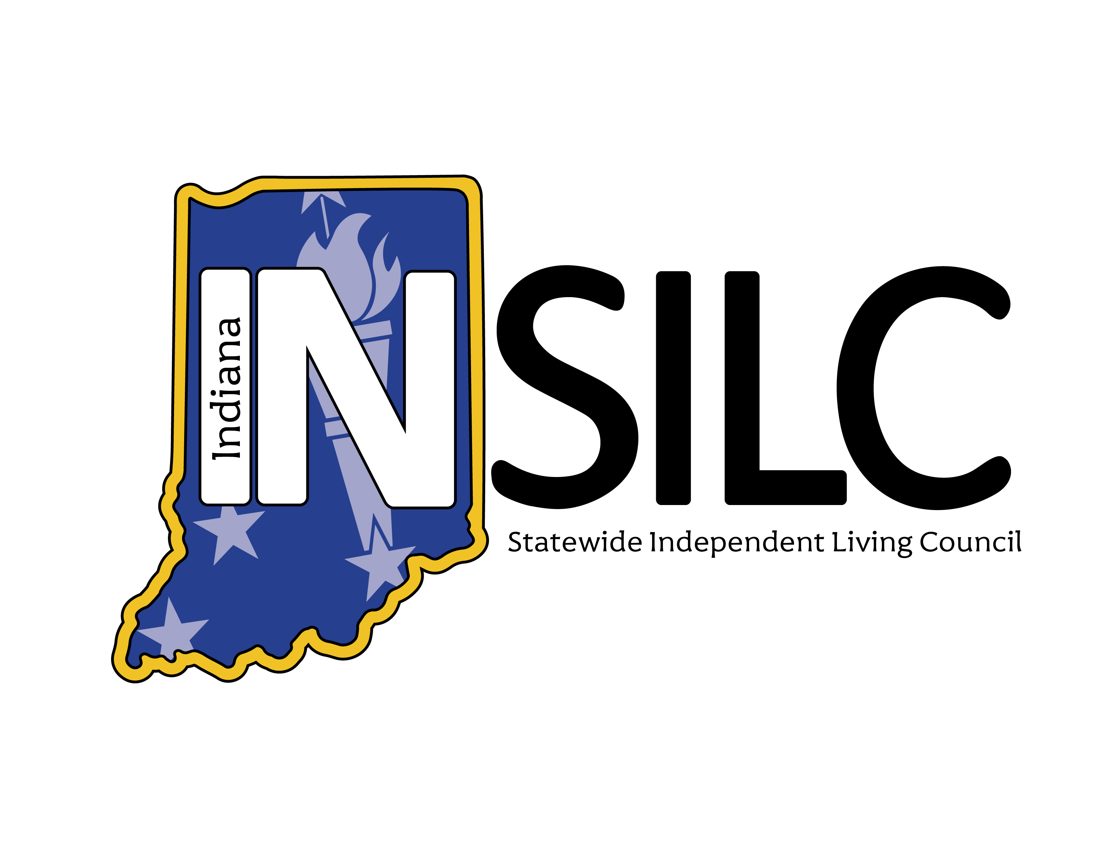

2025-2027 State Plan for Independent Living (State Plan) Dashboard Report
Data from October 1, 2025-March 30, 2026
The following provides a snapshot of progress on the 2025–2027 State Plan for Independent Living, made collectively Indiana’s Independent Living Network.
For questions about this document or to request accommodation, please email us at info@indianasilc.org.
State Plan goals are set up in the following sequence: Goal > Objective > Indicator > Outcomes. Please refer to the full State Plan (linked above) to read the details of the goals, objectives, indicators, and outcomes.
This dashboard tracks the progress of the indicators of the plan by assigning each indicator a status on the following scale:
- Exceeded—a target was exceeded.
- Met—the target was met exactly.
- Substantially Met—greater than 60% and less than 100% was achieved.
- Partially Met—greater than 0 but less than 60% was achieved.
- Not Met—nothing was achieved.
- No Progress—the target was delayed or not started.
For indicators rated partially met, not met, or showing no progress, a remediation plan will outline how progress will be achieved. For details on each indicator, please refer to the 2025 Annual Report linked here.

2026 State Plan Dashboard Publishing Schedule
Friday, May 8 | Y2 Q1 & Q2 Dashboard Published
Friday, August 7 | Y2 Q3 Dashboard Published
Friday, November 6 | Y2 Q4 Dashboard Published

State Plan Goal Progress – Year 2 Q1 & Q2 Compiled Data
Image Description: Bar chart titled “State Plan Indicators – Year 2 Q1 & Q2.” The chart displays counts of objectives by progress category: Exceeded, Met, Substantially Met, Partially Met, Not Met, and No Progress, across five goal-objective combinations. No objectives are shown in the Exceeded, Substantially Met, Not Met, or No Progress categories. In the Met category, Goal 2 Objective 2 shows 4 objectives; Goal 2 Objective 1 and Goal 3 Objective 1 show 2 objectives each. In the Partially Met category, Goal 2 Objective 1 shows 10 objectives; Goal 2 Objective 2 and Goal 3 Objective 1 each show 6 objectives; Goal 1 Objective 1 shows 5 objectives; and Goal 3 Objective 2 shows 4 objectives.

Halfway through Year 2 of the State Plan, 100% of the 39 relevant indicators have made some progress. 80% of the indicators are partially met while the remaining 20% have been met exactly.

Indicator Detail
Click here to find full indicator language, starting on page six of the State Plan.

Goal 1: Strengthen the Indiana Independent Living Network (the Network) and increase resource capacity

Objective 1: Secure additional funding to support and expand the Network
Indicator Status | Count | Percent
Partially Met | 5 | 100%

Goal 1 Objective 1 Indicator Remediation Plans:
- 1.1.1 Funding report shows a 2% increase
  - Partially Met: Network members have made progress in raising additional funds; the 2% increase goal has not yet been reached with only half the year completed. Members will report additional funds raised for the next State Plan dashboard.
- 1.1.2 Service report shows a 2% increase
  - Partially Met: The Centers for Independent Living have made progress to increase the number of services provided; the 2% increase goal has not yet been reached with only half the year completed. Centers will report more services provided for the next State Plan dashboard.
- 1.1.3 Community activities report shows a 2% increase
  - Partially Met: Network members have made progress in increasing community activities; the 2% increase goal has not yet been reached with only half the year completed. Members will report additional community activities for the next State Plan dashboard.
- 1.1.4 Community activities related to systems advocacy show a 2% increase
  - Partially Met: Network members have made progress in increasing community activities related to systems advocacy; the 2% increase goal has not yet been reached with only half the year completed. Members will report additional activities related to advocacy for the next State Plan dashboard.
- 1.1.7 Facilitation of activities that promote increased resources
  - Partially Met: INSILC and the Centers have started meeting to collaborate on joint fundraising efforts. More details about how Network Members will solicit and equitably distribute any funds or resources procured together by the end of Year 2 of the 2025-2027 State Plan.

Goal 2: Increase community capacity to support the Independent Living Network and promote the Independent Living Philosophy statewide

Objective 1: Educate the community on issues impacting people with disabilities to increase awareness and improve outcomes
Indicator Status | Count | Percent
Met or Exceeded | 2 | 16.67%
Partially Met | 10 | 83.33%

Goal 2 Objective 1 Indicator Remediation Plans:
- 2.1.1 Engagement of Persons with Disabilities (PWD) increased via public comments, website comments, or attendance at Network events.
  - Partially Met: The engagement metrics listed above were baselined for Year 1 of the 2025-2027 State Plan, and Network Members are collecting these metrics for Year 2. At the halfway point of the year, the Y2 metrics have not surpassed the Y1 metrics.
- 2.1.2 / 2.1.10 INSILC will host quarterly (4) public input forums, to be held remotely and/or in person at locations throughout the state.
  - Partially Met: In Year 2 Q1 & Q2, INSILC hosted (2) public input forums, keeping this indicator on track to be met by the end of the year.
- 2.1.3 / 2.1.11 INSILC will contribute/lead one (1) Network conference for cross-disability networking opportunities during the State Plan period.
  - Partially Met: INSILC and Independence Indiana are collaborating to host a conference September 29-30, 2026. This indicator will be met by the end of Year 2.
- 2.1.4 / 2.1.8 / 2.2.6 / 3.2.2 Consumer Needs Assessment survey will be collected from PWD seeking input of community challenges and distribute the results as the Community Engagement Report
  - Partially Met: Because there are existing statewide Consumer Needs Assessment surveys, the State Plan Committee decided to host focus groups to capture qualitative data instead. INSILC has begun working with a contractor that will work with the Centers for Independent Living to host focus groups in the summer of 2026. The results will be compiled and distributed to the Network by the end of 2026.
- 2.1.5 Employee reports show a 5% increase in the number of PWD in leadership positions and in employment across the Network
  - Partially Met: Network members are tracking the inclusion of PWD in leadership and employment in the Network. The 5% increase goal has not been met, and likely will not be met, due to limited funding. The Year 2 annual report will share the final composition percentage.
- 2.1.7 At minimum, one (1) position paper will be created each year, based on topics identified by surveys, and distributed throughout the Network.
  - Partially Met: After endorsing/publishing our first position statement in Year 1, the INSILC Council members started discussing procedures for future statements including who authors the statements and who approves them to publish. The discussion will continue at the June 10, 2026 public meeting. INSILC expects to publish a new position statement by the end of Year 2 (September 30, 2026).
- 2.1.9 Information/Satisfaction surveys will be utilized at all Network events to collect data from PWD in leadership/advocacy positions.
  - Partially Met: Some Network members are capturing this information, and others are not. It can be difficult to add questions to surveys or create a new survey. We will continue to collect this information where we can and report the figures in the Year 2 Annual Report.

Objective 2: Gather input from people with disabilities and strengthen peer-to-peer mentorship to elevate their voices statewide
Indicator Status | Count | Percent
Met or Exceeded | 4 | 40%
Partially Met | 6 | 60%

Goal 2 Objective 2 Indicator Remediation Plans:
- 2.2.2 Plain language and Accessible format versions of the State Plan for Independent Living created and distributed.
  - Partially Met: INSILC has selected outside writers specially qualified in plain language to convert the 2025-2027 State Plan into plain language and to assist INSILC in creating a plain language 2027-2030 State Plan. The contract to work with these experts will be approved at the June 10, 2026 Council meeting. We are on track to provide a plain language 2025-2027 State Plan by the end of 2026 and to complete the 2027-2030 plain language State Plan by its deadline in September 2027.
- 2.2.3 / 2.2.5 Quarterly (4) public input sessions held and the number of attendees identified as PWD are recorded with surveys.
  - Partially Met: This indicator is 50% met for the year after hosting 2 public input sessions in December 2025 and March 2026. This indicator will be exceeded once our Town Halls and 2027-2030 State Plan Input Forums are complete for Year 2 of the 2025-2027 Sate Plan. Registration forms and post-event surveys each ask if the respondent identifies as a Person with a Disability.
- 2.2.7 / 3.1.5 Baseline data from inputs analyzed and identification of disability-centric organizations to establish collaborative partnerships.
  - Partially Met: INSILC is in the process of analyzing the data of a survey distributed throughout Year 1 of the State Plan. Early emerging themes are around healthcare, housing, and transportation. INSILC will continue to analyze its survey results, focus group results, and other direct input from consumers to identify areas for partnership.
- 2.2.8 Create a cohesive and collaborative approach to systems change within the state through coalition building.
  - Partially Met: INSILC has made progress in two ways: the first is that INSILC will work with an outside expert to design a cohesive approach to systems change. This outside expert will be approved at the June 10, 2026 Council meeting. The second area of progress is that INSILC has been invited to be part of a statewide coalition called the Indiana Disability Alliance, which will work to prevent re-institutionalization and protect Home and Community-Based Services.

Goal 3: Promote and advocate for full inclusion of people with disabilities in all aspects of community life

Objective 1: Collaborate across the Independent Living Network to reduce barriers and increase awareness of Independent Living Philosophy and the role of Centers for Independent Living
Indicator Status | Count | Percent
Met or Exceeded | 2 | 25%
Partially Met | 6 | 75%

Goal 3 Objective 1 Indicator Remediation Plans
- 3.1.1 Each Network Member will participate annually at minimum two (2) housing-centric meetings in their respective service area.
  - Partially Met: At this point in the year, all Networks members have attended at least one meeting, not yet hitting the benchmark. In total, 26 meetings have been reported by the Network so far.
- 3.1.2 Each Network Member will participate annually at minimum two (2) transportation-centric meetings in their respective service area.
  - Partially Met: At this point in the year, only some Network members have attended at least one meeting, not yet hitting the benchmark. In total, 27 meetings have been reported by the Network so far.
- 3.1.3 Each Network Member will participate annually at minimum two (2) employment-centric meetings in their respective service area.
  - Partially Met: At this point in the year, only some Network members have attended at least one meeting, not yet hitting the benchmark. In total, 35 meetings have been reported by the Network so far.
- 3.1.4 Collection of Network surveys to identify focus areas for collaborative efforts. Survey data from all Network events and public input sessions.
  - Partially Met: While INSILC has begun to identify focus areas for collaboration from its own survey inputs, the Network has not yet compared all survey results to compare emerging trends. INSILC will request survey responses from the Centers to be analyzed alongside the upcoming Focus Group data and 2027-2030 Input Forum data. INSILC aims to have all input sources compiled and ready for analysis by the September 9, 2026 Council meeting.
- 3.1.8 INSILC will formulate a strategic plan for collaborative activities with disability-centric organizations and distribute within the Network.
  - Partially Met: At the June 10, 2026 Council meeting, INSILC will approve a contract with an outside expert to create a strategic plan for collaborative activities across the state; the work will begin shortly thereafter. A final plan is expected to be ready to distribute by December 2026.

Objective 2: Model strategic, cross disability systems change through responsive, innovative practices
Indicator Status | Count | Percent
Partially Met | 4 | 100%

Goal 3 Objective 2 Indicator Remediation Plans:
- 3.2.3 INSILC shall provide information to Indiana's critical entities regarding Emergency Preparedness needs for PWD.
  - Partially Met: INSLC's Emergency Preparedness workgroup has begun meeting and compiling information to be distributed. The workgroup aims to finalize the informational material by September 2026 to begin distribution during Year 3 of the 2025-2027 State Plan.
- 3.2.4 The Network will collaborate with disability-centric organizations to create materials to assist healthcare practitioners to create inclusive access and distribute the materials to over 80 counties.
  - Partially Met: INSILC’s Healthcare Workgroup has begun meeting and compiling information for Indiana practitioners. Materials are expected to be finalized by September 2026 to begin distribution during Year 3 of the 2025-2027 State Plan.
- 3.2.6 One hundred (100) Persons with Disabilities have successfully completed the program.
  - Partially Met: This indicator refers to indicator 3.1.5 which set out to create a self-advocacy program focusing on healthcare and housing in Year 1 of the State Plan. Instead of creating a new curriculum, INSILC chose to partner with The Inclusion Institute, operated by one of the network’s Center for Independent Living called The League. Under 100 people were enrolled in the program during Q1 and Q2 of Year 2 of the State Plan, missing the benchmark of 100. 23 individuals will complete the program in May 2026.

