
INSILC 2025-2027 SPIL Year 1 (2025)
Annual Report

March 2026

Table of Contents

2025-2027 State Plan for Independent Living (SPIL) Overview and Comments 4
SPIL Goals and Objectives Overview 5
2025-2027 SPIL Goal Summary – Year 1 8
Discussion of Goal 1: Build Resource Capacity of the Independent Living Network 10
Objective 1: Secure additional funding to support and expand the IL Network. 10
Goal 2: Community Capacity Increased to Support the IL Network and Promote IL Philosophy throughout the State 15
Objective 1: Hoosiers will better understand the needs and barriers of individuals with disabilities through community education of advocacy, self-determination, and the Independent Living Philosophy. 15
Objective 2: Gathering input of the needs of PWD and promotion of peer-to-peer mentorship resulting in elevating the voices of PWD 23
Goal 3: The Indiana IL Network will promote and advocate for the integration and full inclusion of individuals with disabilities into the mainstream of American society. (Systems Advocacy) 28
Objective 1: The IL Network collaborates to mitigate barriers for Hoosiers who are PWD. 28
Objective 2: The IL Network models strategic, cross-disability systems change through responsive, innovative practices 33

2025-2027 State Plan for Independent Living (SPIL) Overview and Comments

Executive Summary
During the first year of the 2025–2027 State Plan for Independent Living (SPIL), the Indiana Independent Living (IL) Network made solid progress in strengthening its capacity, increasing community engagement, and advancing systems advocacy. The year also revealed areas where some activities were delayed or needed adjustments. These lessons will help improve planning and implementation.

Goal 1: Build Resource Capacity of the IL Network
The IL Network successfully met Goal 1, with most Year 1 indicators either met or exceeded. The network increased funding and service capacity across the Centers for Independent Living (Centers), surpassing annual growth targets. Service delivery expanded across multiple categories, and community activities—including systems advocacy—were above planned benchmarks.
The Network also developed and distributed a Resource Capacity Assessment, receiving responses from all Centers. Although the analysis was not completed within Year 1, the process created a strong data foundation, and analysis has since been finalized to guide future capacity‑building efforts. The delay was not due to structural issues, and the Network plans to complete future analyses more quickly.

Goal 2: Increase Community Capacity and Promote Independent Living Philosophy
Progress toward Goal 2 was mixed. INSILC and the Centers expanded community engagement through public forums, educational events, leadership activities, and statewide outreach. Attendance at town halls and community events increased, showing growing public interest in Independent Living issues.
The Network also improved its collection of consumer input through surveys and forums, but inconsistent data and methodology created challenges. To address this, the SPIL Committee shifted from a traditional needs assessment to a qualitative focus group model to better capture lived experience. Some indicators were only partially completed, but this reflects a strategic shift to improve future data quality.
Several barriers affected progress under this goal, including delays in planning a statewide conference, early survey design issues, and staffing and timing constraints that impacted indicators such as Employee Composition (2.1.5). Corrective steps are underway, including updated survey tools, new workgroups, and scheduled future events.

Goal 3: Systems Advocacy and Cross-Disability Collaboration
Progress on Goal 3 was more limited in Year 1 because the systems‑level work was complex and planned to unfold over multiple years. While the Network met several participation‑based indicators—such as attending housing, transportation, and employment meetings—larger initiatives like emergency preparedness planning, healthcare outreach materials, and collaborative strategic planning were delayed.
These delays were mainly due to needed planning time, limited capacity, and the recognition that some initiatives required outside expertise. To move forward, INSILC created new workgroups late in the year and committed to bringing in external consultants in Year 2 to support planning, coalition building, and emergency preparedness efforts.
Despite these challenges, the Network partnered with disability‑focused organizations to host leadership events and advocacy forums, helping lay a stronger foundation for future cross‑disability systems change.

Overall Progress and Lessons Learned
Taken together, Year 1 of the SPIL showed strong progress in building network capacity, engaging communities, and putting key data and planning systems in place. The findings from this first year helped the IL Network improve evaluation methods, strengthen data consistency, and adjust strategies. These lessons are already shaping Year 2 efforts and are expected to support even greater progress throughout the rest of the SPIL period.

SPIL Goals and Objectives Overview

Goals
The SPIL contains three specific goals to achieve progress toward the mission:

- The Indiana IL Network will work to strengthen the network and increase resource capacity. (Build Resource Capacity of the IL Network)
- Community Capacity Increased to Support the IL Network and Promote IL Philosophy throughout the State (Community Advocacy & Outreach)
- The Indiana IL Network will promote and advocate for the integration and full inclusion of individuals with disabilities into the mainstream of American society. (Systems Advocacy)

Each goal has one or two objectives, and each objective has measurable indicators and targets to measure success. These indicators were selected to show that, if met, the broader objectives were also met.

Objectives and Measurable Indicators
Measurable indicators are the specific data points used to show progress toward an outcome. Programs do not measure outcomes directly; instead, they rely on indicators that provide clear, observable evidence of success. In short, indicators are the concrete data used to track how well each outcome is being achieved.

Of the 43 total indicators in the SPIL, this report measures 33. Thirteen indicators are marked as N/A because they either apply only to Years 2 or 3 of the SPIL, or they require Year 2 data to be evaluated. The Year 1 data in this report serves as the baseline for future comparison.

Evaluation Process Challenges
During Year 1 of the 2025–2027 SPIL, the IL Network identified several challenges that affected how some indicators could be measured and rated. These issues were most common for indicators that needed baseline data, multi‑year comparisons, or activities scheduled for later in the SPIL period.
Some indicators were being measured for the first time or were not tracked consistently early in the year. Without prior‑year data or consistent methods, it was not possible to determine progress, so these indicators were marked as N/A.
Other indicators required Year 2 data—such as those based on analyzing Year 1 inputs or tracking year‑over‑year change. Because this information was not yet available, these indicators were also marked as N/A.
Timing also created challenges. Several indicators required planning, workgroup development, contracting, or coordination across partners before work could begin. If an activity started but did not reach its Year 1 goal, it was rated Partially Met. If it was delayed or not started, it was rated Not Met or No Progress.
Finally, data collection methods varied across the IL Network, especially for surveys and community event feedback. This inconsistency made it difficult to combine results. INSILC will lead conversations with other IL Network members to align data collection methods in the following years.

Evaluation Rating Scale
This report uses an evaluation rating scale that ranges from a high of “exceeding” the target to a low of “no progress”.

- Exceeded—a target was exceeded.
- Met—a target was met exactly.
- Substantially Met—greater than 60% and less than 100% of the target was achieved.
- Partially Met—greater than 0 but less than 60% was achieved.
- Not Met—nothing was achieved.
- No Progress—the target was delayed or not started.

2025-2027 SPIL Goal Summary – Year 1

SPIL Goals Overall Results
18 out of 33 SPIL Objectives were exceeded, met or substantially met (54.5%). An additional 11 indicators had some progress (33.3%). Only 4 indicators were not met or had no progress (12.1%).

Goal 1, Objective 1—Substantially Met
Of the 5 measurable indicators, 4 were exceeded or met (80%), and 1 was partially met.

Goal 2, Objective 1—Partially Met
Of the 11 measurable indicators, 4 were met or substantially met (36.4%), 6 were partially met, and 1 was not met.

Goal 2, Objective 2—Substantially Met
Of the 6 measurable indicators, 4 were met (66.7%) and 2 were partially met.

Goal 3, Objective 1—Substantially Met
Of the 7 measurable indicators, 6 were met or substantially met (85.7%), and 1 was partially met

Goal 3, Objective 2—Not Met
Of the 4 measurable indicators, 1 was partially met, 1 was not met, and 2 had no progress.

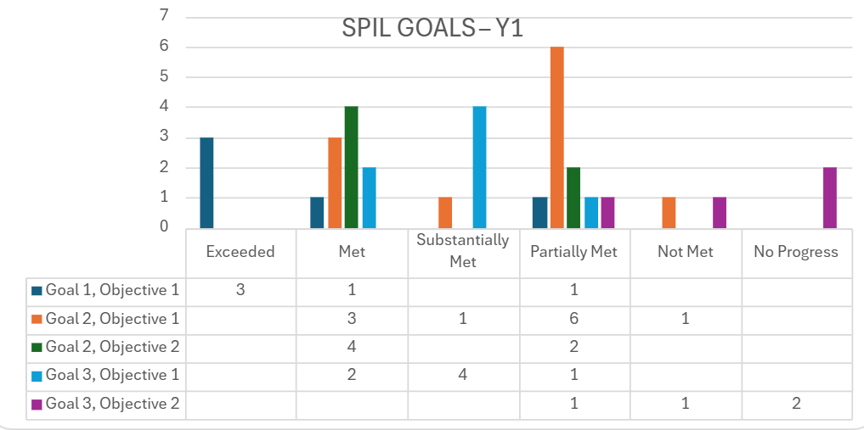

Bar chart titled “SPIL GOALS – Y1” showing counts of outcomes (Exceeded, Met, Substantially Met, Partially Met, Not Met, No Progress) for five goal/objective areas. Goal 1 Objective 1: Exceeded 3, Met 1, Partially Met 1. Goal 2 Objective 1: Met 3, Substantially Met 1, Partially Met 6, Not Met 1. Goal 2 Objective 2: Met 4, Partially Met 2. Goal 3 Objective 1: Met 2, Substantially Met 4, Partially Met 1. Goal 3 Objective 2: Partially Met 1, Not Met 1, No Progress 2.

Discussion of Goal 1: Build Resource Capacity of the Independent Living Network

Objective 1: Secure additional funding to support and expand the IL Network.

Of the 5 measurable indicators, 4 were exceeded or met (80%) and 1 was partially met. The objective was substantially met.

Objective 1 focused on increasing the capacity and infrastructure of the IL Network to increase the independence of people with disabilities through increased services, programs, and community activities.

Additionally, the objective sought to undertake activities that lead to increased capacity and stronger infrastructure.

The measurable indicators looked at:
- The amount of other funding available to the network
- The number of services provided to consumers
- The number of community activities.
- Network-wide Resource Capacity Assessment

Indicator 1: PPR funding report shows a 2% increase annually in other funding.

Result: Exceeded

ACL tracks the following categories of Other Funding called Private Resources in section 1.1.3 of the Program Performance Report (PPR):
- Foundations, Corporations or Trust Grants
- Donations from Individuals
- Membership Fees
- Investment Income/Endowment
- Fees for Service (program income, etc.)
- Other resources (in-kind, fundraising, etc.)

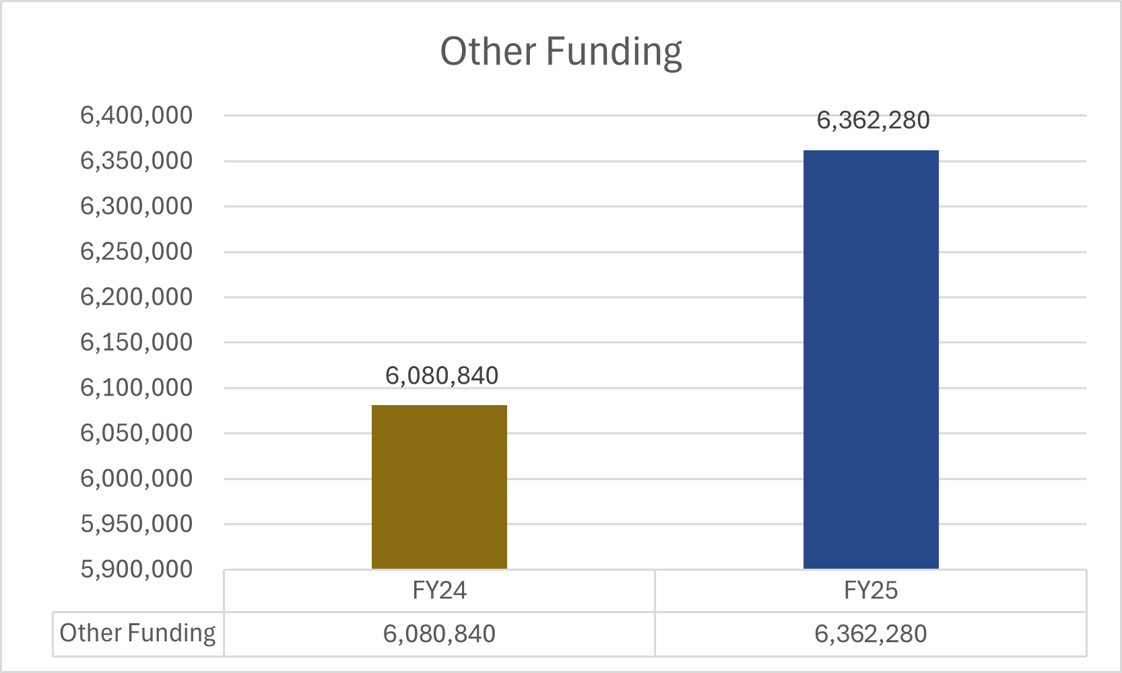
Image Description: Bar chart titled “Other Funding” comparing FY24 and FY25. FY24 shows approximately $6.08 million in other funding, while FY25 shows approximately $6.36 million.

The Other Resources raised by the Centers increased by 4.63% between FY24 and FY25. Eight of the ten centers increased their other funding category by an average of 37%, as shown in this table. Efforts to increase funding will continue.

Other Funding Detail
FY24 | FY25
0 | 0
0 | 0
11,702 | 12,892
15,200 | 23,022
39,900 | 65,137
76,619 | 201,710
138,021 | 152,669
535,165 | 518,788
2,706,121 | 3,117,726
2,558,112 | 2,270,336
Total: $6,080,840 | $6,362,280

Indicator 2: PPR services report shows a 2% increase annually in services provided.

Result: Exceeded

The services provided by the Centers increased by 18.4% between FY24 and FY25, exceeding the indicator measure.

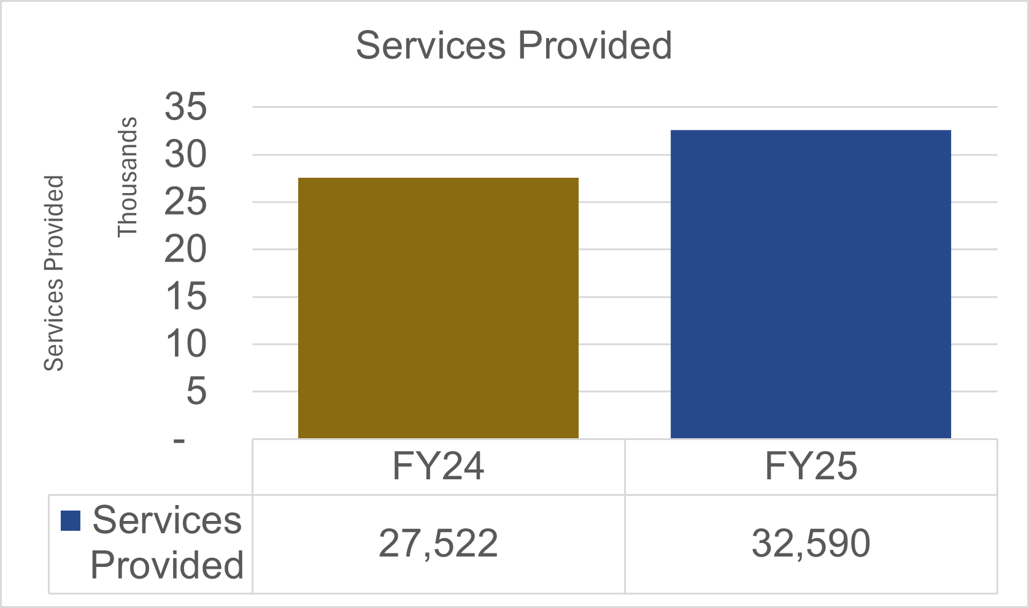
Image description: Bar chart titled “Services Provided” comparing FY24 and FY25. The y-axis is labeled “Services Provided (Thousands).” FY24 shows 27,522 services provided, while FY25 shows 32,590 services provided, indicating an increase from FY24 to FY25.
There was a significant increase between the two years in three service categories: advocacy/legal services, counseling, and recreation, as shown by the table below. The data indicates a significant year-over-year increase in three service categories: advocacy/legal services, counseling, and recreation. These changes are detailed in the table below.

Service | Percent Change FY24 to FY25
Advocacy/Legal Services | 32.36%
Counseling | 415.38%
Recreation | 76.26%

Indicator 3: PPR community activities report shows a 2% increase annually.

Result: Exceeded

Community activities conducted by the Centers and INSILC increased by 42.5%.

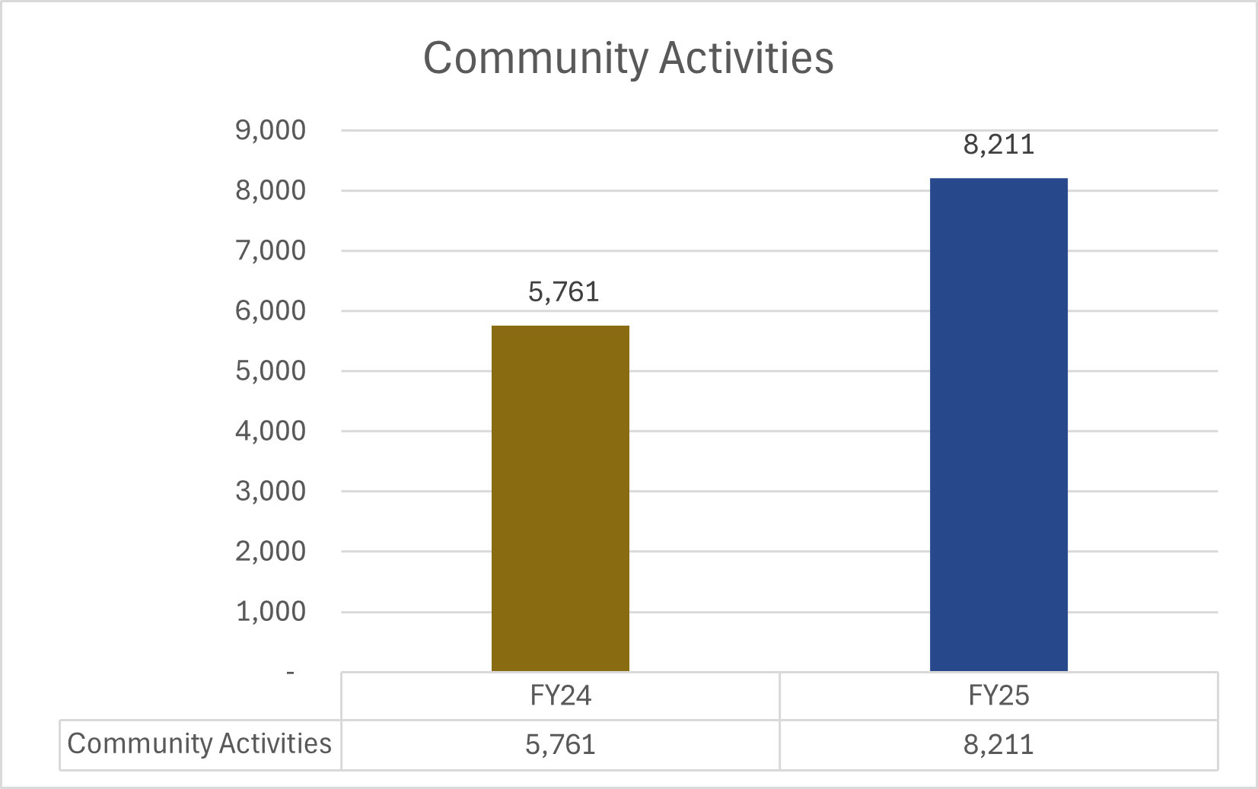

Image description: Bar chart titled “Community Activities” comparing FY24 and FY25. FY24 shows 5,761 community activities, and FY25 shows 8,211 community activities, indicating a substantial increase from FY24 to FY25.

Indicator 4: Community activities related to systems advocacy show a 2% increase annually

Result: N/A

In the FY24 SPIL Extension, a comparable indicator examined community activities related to systems advocacy; however, no data was reported by the end of that cycle. As a result, FY25 serves as the first year of data collection for this indicator.
The table below presents the number of hours reported by each Center for Independent Living and INSILC for community activities supporting systems advocacy. The data are displayed in numerical order. Two Centers did not submit data. A total of 869.5 hours were reported in FY25. Because this is the first year of data collection, there is no baseline or trend for comparison, and the indicator is marked N/A for measurement status.

Hours of Systems Advocacy Activities Reported by Each Center and INSILC for FY25
Not Reported
Not Reported
4.0
6.5
8.0
15.0
49.5
55.5
153.0
185.0
393.0
Total: 869.5

Indicator 5: IL Network Resource Capacity Assessment will collect data from all IL members. Results will be collected, analyzed, and collaboration methods initiated. Year 1 – Quarters 1 & 2 Resource Capacity Assessment will be created and distributed to the IL Network Members.

Result: Met

In Q2 of FY25, a Data Analysis Workgroup was formed to work on the Resource Capacity Assessment. In September 2025, the workgroup reviewed and approved the survey created by the workgroup and recommended distribution to the Centers for Independent Living.

The survey was sent to all ten Centers and garnered 10 responses (100%).

Indicator 6: IL Network Resource Capacity Assessment will collect data from all IL members. Results will be collected, analyzed, and collaboration methods initiated. Year 1 – Quarters 3 & 4 Analysis of Resource Capacity Assessment will result in the identification and development of supports needed in the IL Network.

Result: Partially Met

This indicator was partially met. By the end of Q4, data analysis was underway; however, the identification of needed supports was not completed within Year 1. Since that time, the analysis has been finalized, and the required supports have now been identified: funding, housing, and marketing for the IL Network. There will be a fundraising workgroup convened in April 2026 to explore and move forward with new funding opportunities for the IL Network.

Indicator 7: IL Network Resource Capacity Assessment will collect data from all IL members. Results will be collected, analyzed, and collaboration methods initiated. Years 2 & 3 – Creation and facilitation of collaborative activities that promote increased resources within the IL Network.

Result: N/A

Goal 2: Community Capacity Increased to Support the IL Network and Promote IL Philosophy throughout the State

Objective 1: Hoosiers will better understand the needs and barriers of individuals with disabilities through community education of advocacy, self-determination, and the Independent Living Philosophy.

Of the 11 measurable indicators, 4 were met or substantially met (36.4%), 6 were partially met (54.5%) and 1 was not met (9.1%). The objective was partially met.

The measurable indicators looked at:
- Engaging PWD online and in-person
- Consumer Needs Assessment Survey
- Employee Composition
- Education and advocacy activities like workshops, events and other resources
- Position Papers
- Information/Satisfaction Surveys at IL Network Events

Indicator 1: Engagement of Persons with Disabilities increased via public comments, website comments, or attendance at IL Network events

Result: N/A

This was the first year of data collection for this indicator, which created some challenges because several Centers began tracking these data partway through the year. The table below displays the number of public comments, website comments, and event attendance reported by the Centers and INSILC, listed in the order received. Two Centers did not submit data. The designation ‘Not Collected’ indicates that a Center submitted overall data but did not have information for those specific categories.

Because this was the first year of data collection, no year-over-year comparison can be made. As a result, the indicator is marked N/A for measurement status. The Year 1 results will serve as the baseline for Year 2.

In Year 2, the Network will work collaboratively to establish shared definitions for all data points to ensure consistent, high-quality reporting across the Network.

Data Collected by the IL Network for FY25
Number of Public Comments | Number of Website Comments | Attendance at IL Network Events (Number of People)
Not Reported | Not Reported | Not Reported
Not Reported | Not Reported | Not Reported
25 | 0 | 25
87 | 327 | 155
27 | 47 | 2,737
Not Collected | Not Collected | 1,500
49 | 7 | 293
5 | 10 | 23
0 | 12 | 39
123 | 607 | 2,011
0 | 0 | 3,203
Total: 316 | Total: 1,010 | Total: 9,986

Indicator 2: INSILC will host quarterly public input forums to be held remotely and/or in-person at locations throughout the state.

Result: Met
- Virtual – December 2024
- Lafayette – March 2025
- South Bend – July 2025
- Evansville – September 2025

INSILC held four town halls in FY25—one virtual and three in-person at the locations listed above.

Attendance increased steadily after the second town hall, with a total of 217 participants across all four events.

This represents a substantial increase in public engagement compared to prior years, indicating that more people with disabilities are choosing to participate and share their perspectives.”

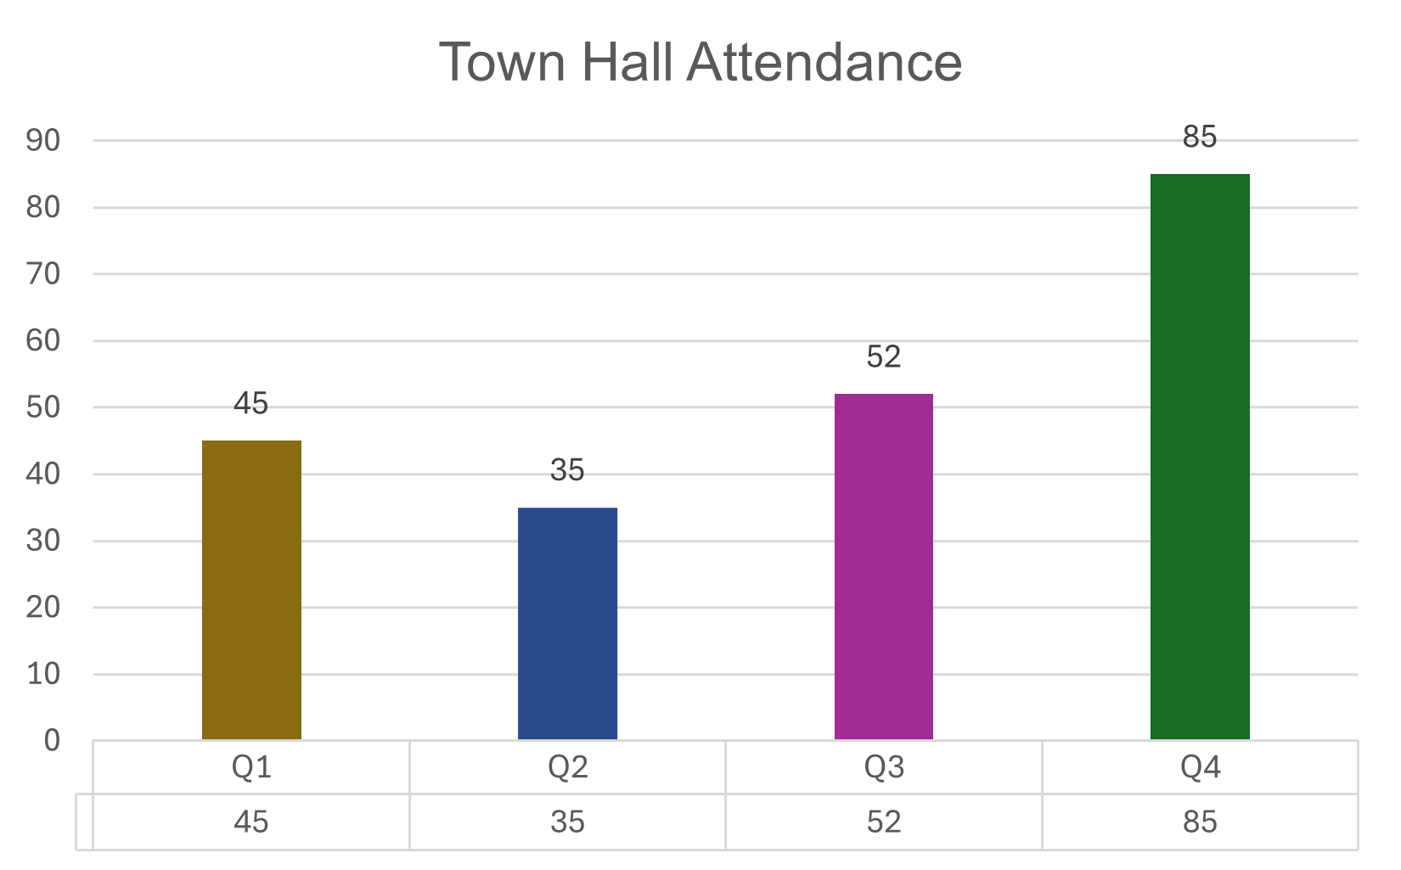

Bar chart titled “Town Hall Attendance” showing quarterly attendance totals. Q1: 45 attendees. Q2: 35 attendees. Q3: 52 attendees. Q4: 85 attendees (highest). Attendance decreases from Q1 to Q2, then increases in Q3 and rises sharply in Q4.

Indicator 3: INSILC will contribute/lead to one IL Network conference for cross disability networking opportunities during the SPIL period.

Result: Partially Met

The last network-wide conference held by Independence Indiana was in 2024; since then, the planning group continued to meet and determined it would not be feasible to host a conference in 2025 given the economic uncertainty in today’s climate. However, dates for a network-wide conference have been set for September 29-30, 2026. INSILC will be working closely with Independence Indiana to produce the multi-day event.

Indicator 4: Consumer Needs Assessment survey will be collected from PWD seeking input of community challenges & barriers, including physical, linguistic, emotional, cultural, cognitive, and systemic.

Result: Partially Met

In Q2 of FY25, a Data Analysis Workgroup was established to guide development of the statewide Consumer Needs Assessment. The workgroup included representatives with expertise in independent living services, data interpretation, and community engagement. After reviewing the existing Consumer Needs Assessment findings and other available reports, the group determined that additional qualitative data would provide meaningful context to complement the quantitative and narrative information already collected.

To inform its planning, the workgroup also reviewed publicly available data sources to inform their planning, including U.S. Census Bureau American Community Survey (ACS) disability estimates, CDC Behavioral Risk Factor Surveillance System (BRFSS) data, Centers for Medicare & Medicaid Services (CMS) utilization data, Social Security Administration (SSA) disability beneficiary statistics, HUD housing data, and relevant Indiana state agency reports (such as DDRS and FSSA publications). While these datasets offer valuable insight into important demographic, economic, health, and service utilization trends, the workgroup emphasized the importance of hearing directly from individuals with disabilities regarding emerging barriers, service gaps, and communities priorities.

Based on this analysis, the workgroup refined its approach and will reconvene in 2026 to conduct a structured series of focus groups across the state. The newly established Focus Group Workgroup will begin meeting in March 2026 with focus groups scheduled to launch in Summer 2026.

Indicator 5: PPR Employment Composition shows a 5% increase in the number of PWD in leadership positions and in employment across the IL Network during the SPIL period

Result: Partially Met

In FY24, there were 26 people with disabilities serving in leadership positions within Indiana’s Independent Living Network. In FY25, that number increased to 27, representing a 3.8% increase. While this reflects modest growth, the indicator benchmark was not fully met during this reporting period.
CIL Directors have noted that available funding is currently the primary limitation to expanding leadership opportunities for people with disabilities. Resource constraints affect the ability to grow staffing structures, offer competitive compensation, and invest in leadership development, recruitment, and mentorship initiatives.
To move this work forward, the Independent Living Network will develop a more accurate and feasible method for assessing progress on this objective. This will include identifying training and professional development opportunities that prepare staff to transition into leadership roles as positions become available.
To better understand the leadership composition across the network, INSILC will have conversations with the Centers to gather additional information about governance structures, executive leadership pipelines, board composition, and succession planning practices. This outreach will help identify opportunities, barriers, and promising practices related to advancing people with disabilities into leadership roles. These conversations will begin February 2026.

As part of a remediation strategy, the Council and network partners will prioritize intentional recruitment, mentorship, and leadership development efforts aimed at increasing representation of people with disabilities in executive, managerial, and board-level positions. If leadership openings emerge during the next reporting cycle, the Centers and INSILC will implement strengthened recruitment practices, including targeted outreach to qualified candidates with disabilities and expanded promotion of leadership pathways within the Independent Living Network. These efforts are intended to support steady progress toward meeting the established benchmark in future years.

Indicator 6: Workshops, events, and other information resource sessions for education and advocacy throughout the IL Network

Result: Substantially Met

This indicator does not have any specific benchmarks; however, the Centers and INSILC did participate in community activities related to education and advocacy, as listed in the table below. Two centers did not report this data. The data is shown in numerical order.

Although the indicator does not specify a required number or increase in events, all reporting Network members participated in at least one activity within this category. Therefore, the indicator is considered substantially met.”

Total Number of Events Attended or Hosted Related to Education and/or Advocacy for Each Center and INSILC
Not Reported
Not Reported
2
10
14
26
27
29
33
37
76
Total: 254

Indicator 7: At minimum, one position paper will be created each year (based on topics identified by IL Network surveys) and distributed at workshops, events and other info resource sessions throughout the IL Network. Created position papers will be reviewed and updated annually.

Result: Partially Met

In response to frequent public comments and stakeholder interest, a guardianship and alternatives to guardianship workgroup was formed in Q2 of FY2025 to examine issues related to guardianship and alternatives to provide guidance to the SPIL Committee.

The workgroup undertook a thorough review of guardianship practices, Independent Living philosophy, and the role of Centers for Independent Living. Through this process, the group reviewed a person's legal right to obtain guardianship versus the fact that guardianships are not supported by Independent Living Philosophy. Conflating these two concepts caused hesitation amongst the workgroup to adopt the NCIL Guardianship Position Statement.

The workgroup was ended as planned and then requested and received approval from the SPIL Committee to refine its focus and rename itself solely the Alternatives to Guardianship Workgroup. This change more accurately reflects its purpose of promoting education, resources, and practices that align with IL values. At the same time, the workgroup was reforming, INSILC received public concern and anger about the decision not to adopt the NCIL Guardianship Position Statement, confirming the need to focus on alternatives to guardianship and adopting the NCIL statement.

Following additional discussion at the SPIL Committee level, including consideration of public input and a review of the Council’s authority and responsibilities, the SPIL Committee will present the NCIL Guardianship Position Statement to the full Council for consideration and vote at the March meeting. This ensures that the Council, as the governing body, issues a clear and informed determination consistent with Independent Living philosophy and federal requirements.

Indicator 8: Consumer Needs Assessment survey results/report will be distributed for advocacy by the IL Network.

Result: Partially Met

As stated previously in this report, the Data Analysis Workgroup recommended that the SPIL Committee pursue a series of focus groups as an alternate to a consumer needs assessment. It was determined that it would be valuable to have qualitative data to accompany existing quantitative consumer needs data. Once the groups have been conducted and analyzed, a report will be created and distributed by Q1 of FY2027. The Focus Group Workgroup will begin meeting in March 2026 and focus groups will start Summer 2026.

Indicator 9: Information/Satisfaction surveys will be utilized at all IL Network community events to collect data of PWD participation on community boards, committees, workgroups and other leadership/advocacy positions.

Result: Not Met

The Network did not capture this data in Year 1. The Information/Satisfaction survey that was distributed by INSILC did not include a question capturing leadership/ advocacy positions; neither did the surveys of the Centers.

As of Quarter 2 of 2026, INSILC has added this question to its survey and will begin discussions with the Centers in February 2026 to determine the most effective method for collecting this data moving forward.”

Indicator 10: Each year, INSILC hosts quarterly public input forums in different regions of the state and/or remotely.

Result: Met
- Virtual – December 2024
- Lafayette – March 2025
- South Bend – July 2025
- Evansville – September 2025

INSILC hosted four town hall events in FY2025, the first being virtual, and the second being in three varied locations. Each event was a success in its own way, with Evansville being a standout. The Evansville town hall had the best attendance of 85 with 10 vendors and garnered three media mentions, including a tv news story.

Indicator 11: INSILC will contribute/lead one IL Network Conference for cross disability networking opportunities during the SPIL period.

Result: Partially Met

The last network-wide conference held by Independence Indiana was in 2024; since then, the planning group continued to meet and determined it would not be feasible to host a conference in 2025 given the economic uncertainty in today’s climate. However, dates for a network-wide conference have been set for September 29-30, 2026. INSILC will be working closely with Independence Indiana to produce the multi-day event.

Indicator 12: INSILC will host/collaborate to provide a minimum of two forum events annually that provide leadership development opportunities

Result: Met

The first town hall held had a focus on the effects of the most recent election and the potential impacts of the then-upcoming legislative session. Lobbyist Jennifer Hallowell gave a presentation about the legislative process, including how people can get involved and show leadership by making their voices heard with their elected representatives.

The second event held that meets the qualification of this indicator was an Accessible Transportation Symposium. Hosted in Evansville, the event brought together three types of participants: elected officials, advocates, and people with lived experience. Together, the participants were split into rooms that looked at how accessible transportation or the lack thereof impacts by the following: healthcare, community engagement, and employment. Each group collaborated to develop actionable, real-world plans designed to be implemented over a six-month period.

Objective 2: Gathering input of the needs of PWD and promotion of peer-to-peer mentorship resulting in elevating the voices of PWD

Of the 6 measurable indicators, 4 were met (66.7%) and 2 were partially met (33.3%). The objective was substantially met.

The measurable indicators looked at:
- Increasing the number of PWD who interact with the SPIL
- Creating a plain language version of the 2025-2027 SPIL
- Hosting quarterly public input sessions
- Conducting Information/Satisfaction surveys at all IL Network community events
- Conducting a Consumer Needs Assessment
- Connecting with other disability-centric organizations to create cohesive approach to systems change
- Contributing/leading activities with disability-centric organizations
- Hosting events that provide leadership development opportunities

Indicator 1: Increased number of PWD who interact with the SPIL measured by attendance at SPIL Committee meetings and/or provided public feedback

Result: N/A

In FY25, a total of 83 individuals attended SPIL meetings. Attendance data were not collected in FY24; therefore, a percentage increase cannot be calculated for this reporting period, and the indicator is marked as N/A. FY25 attendance will serve as the baseline for assessing increases or decreases in Year 2.

Regarding public comments, INSILC received 49 comments submitted during public meetings. However, the number of comments received specifically at SPIL meetings and town hall events was not tracked. INSILC will begin capturing these counts in FY26 to support more complete reporting in Year 2.

Indicator 2: Plain language and Accessible format versions of the State Plan for IL created and distributed.

Result: Partially Met

To increase accessibility, the current SPIL has been published in multiple formats, including Word and PDF versions with and without tables to support different accessibility needs, and is available upon request in large print or braille. In alignment with federal screen-readability guidelines, the document incorporates accessible design features such as the use of structured headings and styles, a non-table version, and the avoidance of color coding, ensuring compatibility with assistive technology. Additionally, INSILC has begun working with an outside professional to develop plain-language versions of the current and future SPILs to increase accessibility.

As of January 2026, the SPIL Committee is reviewing proposals from plain language specialists to create a plain-language version of the 2025-2027 and 2027-2030 SPILs. We will have a final decision at the May 18, 2026 SPIL Public Meeting.

Indicator 3: Quarterly public input sessions held and the number of attendees who identify as a PWD are recorded with Information/Satisfaction surveys

Result: Met

At each of the public town halls held in 2025, surveys were distributed that asked in part if the respondent was a person with a disability. We have the total number of surveys submitted in FY25, which was 15, and the percentage of those respondents with a disability was 20%. However, we cannot say how many people with a disability attended each town hall event.

At each public town hall held in 2025, attendees were invited to complete a survey that included a voluntary question asking whether the respondent identified as a person with a disability. In FY25, a total of 15 surveys were submitted, and 20% of respondents identified as having a disability. Because surveys were not collected from all participants, these data reflect only the characteristics of survey respondents, not the full attendance. Therefore, while we can report the percentage of respondents who are identified as people with disabilities, we cannot determine the number of participants with disabilities at each individual town hall. INSILC is exploring ways to increase the survey response rate.

Indicator 4: Years 1-3 Information/Satisfaction Survey from all IL Network community events

Result: Met

During FY25, INSILC distributed an Information/Satisfaction Survey, referred to as the Public Feedback Survey, and received 15 responses. Respondents included individuals with disabilities, family members, and community stakeholders. Feedback themes included healthcare, housing, and transportation.

This input provided meaningful insight into areas where communication, outreach, and education efforts can be strengthened. While the number of responses was modest, the qualitative feedback helped inform ongoing planning discussions.

The Network recognizes that survey distribution and collection practices may vary across the Centers, particularly at community events and outreach activities. To promote greater consistency and strengthen data collection efforts, INSILC will convene a network-wide meeting in Year 2 focused specifically on improving the process for gathering public input across the Independent Living Network. During this meeting, INSILC will collaborate with the Centers to review current practices, identify effective strategies, and develop shared guidance for survey distribution, accessibility, follow-up, and data reporting.

Through this coordinated effort, the Network aims to increase response rates, ensure accessibility across formats, and establish greater consistency in how consumer and community feedback is captured and used to inform SPIL implementation.

Indicator 5: Years 1-3 Quarterly public input sessions

Result: Met
- Virtual – December 2024
- Lafayette – March 2025
- South Bend – July 2025
- Evansville – September 2025
- Discuss panel questions and survey questions

The quarterly town halls held on the dates listed above each offered two routes of public input: interaction with the panel and/or breakout sessions and the post event survey. At the three in-person events, people were able to give feedback about local issues to local leaders. At all four events, participants had the chance to give feedback via survey.

Indicator 6: Years 1-3 Consumer Needs Assessment survey

Result: Partially Met

In Q2 of FY25, a Data Analysis Workgroup was established to guide development of the statewide Consumer Needs Assessment. After reviewing existing findings and publicly available data sources, the group determined that additional qualitative input was needed to complement existing data. As a result, the workgroup refined its focus and will reconvene in 2026 to conduct structured focus groups across the state to better understand emerging barriers, service gaps, and community priorities.

In February 2026, the SPIL Committee will approve the new Focus Group Workgroup, which will begin the planning process of the focus groups this spring. The focus groups will be held with our target outreach groups: youth, veterans, racial/ethnic minorities, and rural residents. The Focus Group Workgroup will begin meeting in March 2026 and focus groups will start Summer 2026.

Indicator 7: Years 2 & 3 Baseline data from inputs analyzed and identification of disability-centric organizations to establish collaborative partnerships

Result: N/A

Indicator 8: Years 2 & 3 Connection with other disability centric organizations—create a cohesive and collaborative approach to systems change within the state through coalition building

Result: N/A

Indicator 9: Years 2 & 3 INSILC contributes/leads at least two activities annually with disability centric organizations (meetings, events, forums)

Result: N/A

Indicator 10: INSILC hosts a minimum of two forum events annually that provide leadership development opportunities

Result: Met

There were two events in FY25 that offered leadership development opportunities. The first was the Virtual Town Hall in December 2024. The event covered how a bill becomes a law and gave tips on how to engage with elected officials and legislative members. This event hosted 45 individuals.

The second opportunity was at the Accessible Transportation Symposium in Evansville, IN. The symposium body was split into three groups that looked at how transportation or the lack of it impacts healthcare, employment, and community engagement. Participants worked together to create a real-world plan related to their breakout room, developing their leadership skills. This event hosted 75 individuals.

Goal 3: The Indiana IL Network will promote and advocate for the integration and full inclusion of individuals with disabilities into the mainstream of American society. (Systems Advocacy)

Objective 1: The IL Network collaborates to mitigate barriers for Hoosiers who are PWD.

Of the 7 measurable indicators, 2 were met (28.6%), 4 were substantially met (57.1%), and 1 was partially met (14.3%).

The measurable indicators looked at:
- Network members participating in housing-centric meetings
- Network members participating in transportation-centric meetings
- Network members participating in employment-centric meetings
- Collection of inputs from Network surveys
- Connections and partnerships with disability-centric organizations
- Leading activities with disability-centric organizations
- Formulating a strategic plan for collaborative activities with disability-centric organizations

Indicator 1: Each IL Network Member will participate annually in two housing-centric meetings in their respective service areas.

Result: Substantially Met

The table below shows the total number of housing-centric meetings attended by each Center for Independent Living and INSILC. Because one center did not attend any housing meetings, we cannot say this indicator was met. However, because other Centers attended more than two events, the Network collectively participated in 56 housing-focused meetings making this indicator substantially met. The data is shown in numerical order, and two centers did not report their data.

In Year 2, the Network will work collaboratively to strengthen data collection for this indicator, including establishing clear definitions for each category to ensure consistency and improve the overall quality of reported data.

Total Number of Housing-Centric Meetings Attended by Each Center and INSILC
Not Reported
Not Reported
0
2
2
3
5
10
10
12
12
Total: 56

Indicator 2: Each IL Network member will participate annually in two transportation-centric meetings in their respective service areas.

Result: Substantially Met

The table below shows the total number of transportation-centric meetings attended by each Center for Independent Living and INSILC. Because one center did not attend any transportation meetings, we cannot say this indicator was met. The data in this table is shown in numerical order; two Centers did not report their data. However, because other Centers attended more than two events, the total number of housing meetings attended by the network was 66, making this indicator substantially met.

Total Number of Transportation-Centric Meetings Attended by Each Center and INSILC
Not Reported
Not Reported
0
1
2
2
3
4
15
16
23
Total: 66

Indicator 3: Each IL Network member will participate annually in two employment-centric meetings in their respective service areas.

Result: Substantially Met

The table below shows the total number of employment-centric meetings attended by each Network member. The results are shown in numerical order; two centers did not report their data. The Network attended 69 employment-centric meetings. Because 100% of the reporting Centers attended at least two meetings, this indicator is substantially met.

Total Number of Employment-Centric Meetings Attended by Each Center and INSILC
Not Reported
Not Reported
3
3
4
4
4
6
10
10
25
Total: 69

Indicator 4: Years 1-3 Collection of inputs from IL Network surveys to identify focus areas for collaborative efforts. Information/Satisfaction Survey data from all IL Network community events, quarterly public input sessions, and consumer needs assessment surveys.

Result: Met

IL Network surveys are currently composed differently between the Centers and INSILC, making it difficult to compile data. Moving forward, INSILC and the Centers will collaborate on creating consistent survey language to address this indicator.

Indicator 5: Years 2 & 3 Baseline data from inputs analyzed and identification of disability-centric organizations to establish collaborative partnerships. Evaluation of data will occur annually to review and identify new focus areas defined by data results.

Result: N/A

Indicator 6: Connection and partnerships with other disability-centric organizations established—creating a cohesive and collaborative approach to systems change within the state through coalition building

Result: Substantially Met

The table below shows the total number of connections with other disability-centric organizations established by the Network members. The numbers are displayed in numerical order. One center reported they did not track this indicator; two centers did not report any data for this indicator. This is the first year this data was collected and will serve as a baseline for reporting in Year 2. Because not all centers reported data in this category, this indicator status is substantially met.

The Network will continue to collaborate with each other and with other disability-centric organizations to approach systems change in a systemic way.

Total Number of Connections Made by
Each Center and INSILC
Not Reported
Not Reported
Not Collected
6
7
8
10
10
12
25
30
Total: 108

Indicator 7: INSILC contributes/leads at least two activities annually—meetings, events, forums with disability centric organizations.

Result: Met

This indicator was met through two events INSILC hosted in 2025: the Lafayette Town Hall and the Accessible Transportation Symposium. The first was held in Lafayette, Indiana in March and was in conjunction with a resource fair hosted by The Oasis Community. The mission of OASIS Community is to create and maintain an inclusive, safe, person-centered housing community for adults with intellectual or developmental disabilities (IDD). The impact of these events being held on the same day near the same time improved attendance at the Town Hall.

The second event that meets the indicator is the Accessible Transportation Symposium INSILC hosted in partnership with The League’s Inclusion Institute. The Inclusion Institute is focused on working from the outside in–advocating for systemic change, which leads to change in communities and a positive impact on individuals. This partnership led to a dynamic event that offered leadership development opportunities for people with disabilities in Evansville.

Indicator 8: INSILC will formulate a strategic plan for collaborative activities with disability-centric organizations and distribute within the IL Network—will promote collaboration with local Centers during facilitation of activities.

Result: Partially Met

In the first year, some progress was made on creating a strategic plan that outlines collaborative activities with disability-centric organizations. Although we did have meaningful collaborations with some disability-centric organizations, they were not the product of a strategic plan. As of January 2026, the INSILC has begun reviewing proposals from Strategic Planning entities to contract with on creating a cohesive plan. The Council will approve a facilitator at the March 11, 2026 meeting and work will begin the following month.

Objective 2: The IL Network models strategic, cross-disability systems change through responsive, innovative practices

Of the 4 measurable indicators, 1 was partially met (25%), 1 was not met (25%), and 2 had no progress (50%). The objective was not met.

The measurable indicators looked at:
- Facilitating an Emergency Preparedness Committee
- Annually conducting a Consumer Needs Assessment survey
- Providing statewide emergency entities information regarding needs of PWD
- Creating cohesive package of materials for healthcare practitioners
- Facilitating a self-advocacy curriculum program

Indicator 1: Year 1 INSILC convenes and facilitates an Emergency Preparedness Committee. This committee will consist of membership representatives from across Indiana and its primary focus will be to advance collective efforts related to both individual and community disaster preparedness.

Result: No Progress

In December 2025, INSILC formed an Emergency Preparedness Workgroup; members will be approved at the February 16, 2026 SPIL meeting. The workgroup will begin meeting in March 2026.

Indicator 2: Annually a Consumer Needs Assessment will be conducted and distributed as the Community Engagement Report.

Result: Not Met

Because the SPIL Committee, per the Data Analysis workgroup’s recommendation, approved the pursuit of focus groups in lieu of a consumer needs assessment, one was not distributed as the ‘Community Engagement Report.’ However, once the findings of the focus groups are compiled, they can and will be distributed as such.
The new Focus Group workgroup is being formed and will be approved at the February 2026 SPIL Committee meeting. Focus groups will begin this summer; we aim to have a report by the end of 2026.

Indicator 3: Years 2 & 3 INSILC shall provide information to the Indiana Department of Health Services, the Indiana Department of Homeland Security Emergency Management Division, and other critical entities regarding needs for PWD.

Result: N/A

Indicator 4: Year 1 & 2 The IL Network will collaborate with disability-centric organizations to create a cohesive package of resource materials that will assist Hoosier healthcare practitioners to create avenues for inclusive healthcare in a safe and dignified manner for all PWD. Resource package materials will be distributed to 1,000 providers across a minimum of 80 counties.

Result: No Progress

As of January 2026, a Healthcare Workgroup has been established and membership is being developed. The Workgroup will be approved at the February 16, 2026 SPIL Committee meeting. The workgroup will begin meeting in March 2026.

Indicator 5: Year 1 The IL Network will collaborate with other disability-centric organizations to lead/facilitate a self-advocacy curriculum program. This curriculum will be created and facilitated by and for PWD with an additional, intensive focus on healthcare and housing access.

Result: Partially Met

The INSILC Accessible Transportation Symposium was developed using The League’s Inclusion Institute model, which licenses a program format designed to place participants in the role of self-advocates. While this opportunity provided valuable experience, it did not address the specified focus areas of healthcare and housing. To align more closely with the intent of the indicator, the 2026 statewide conference will include programming that directly supports self-advocacy related to healthcare and/or housing.

Additional collaboration across the Network will occur in 2026 to develop programming that incorporates a formal self-advocacy curriculum. INSILC will begin coordinating with the Centers in February 2026 to advance this work.”

Indicator 6: Year 2 (100) Persons with Disabilities have successfully completed the program.

Result: N/A

