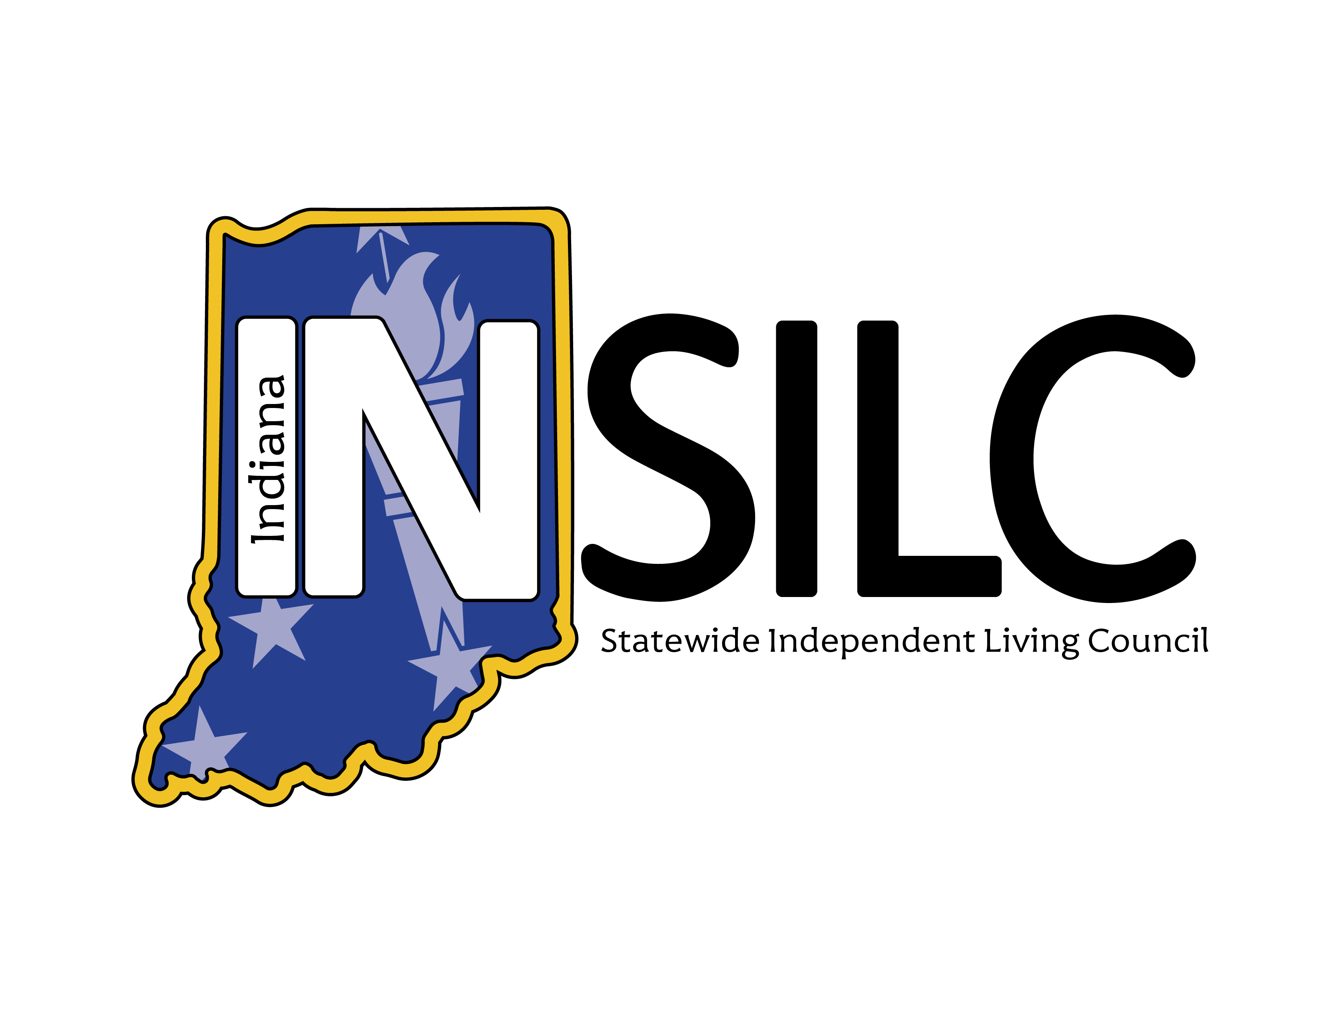

2025-2027 State Plan for Independent Living (SPIL) Dashboard Report
Data from October 1-2024-September 30, 2025
The following provides a snapshot of progress on the 2025–2027 SPIL, made collectively by the Independent Living Network in Indiana. For questions about this document or to request accommodation, please email us at info@indianasilc.org.
SPIL goals are set up in the following sequence: Goal > Objective > Indicator > Outcomes. Please refer to the full SPIL (linked above) to see the full details of the goals, objectives, indicators, and outcomes.
This dashboard tracks the progress of the indicators of the SPIL by assigning each indicator a status from the following scale:
- Exceeded—a target was exceeded.
- Met—a target was met exactly.
- Substantially Met—greater than 60% and less than 100% of the target was achieved.
- Partially Met—greater than 0 but less than 60% was achieved.
- Not Met—nothing was achieved.
- No Progress—the target was delayed or not started.
For indicators rated partially met, not met, or showing no progress, a remediation plan will outline how progress will be achieved. For details on each SPIL indicator, please refer to the 2025 Annual Report linked here.

2026 SPIL Dashboard Publishing Schedule
April 1-April 30 | Y2 Q1 & Q2 Data Collection
Friday, May 8 | Y2 Q1 & Q2 Dashboard Published
July 1-July 31 | Y2 Q3 Data Collection
Friday, August 7 | Y2 Q3 Dashboard Published
October 1-October 31 | Y2 Q4 Data Collection
Friday, November 6 | Y2 Q4 Dashboard Published

SPIL Goal Progress – Year 1 Compiled Information
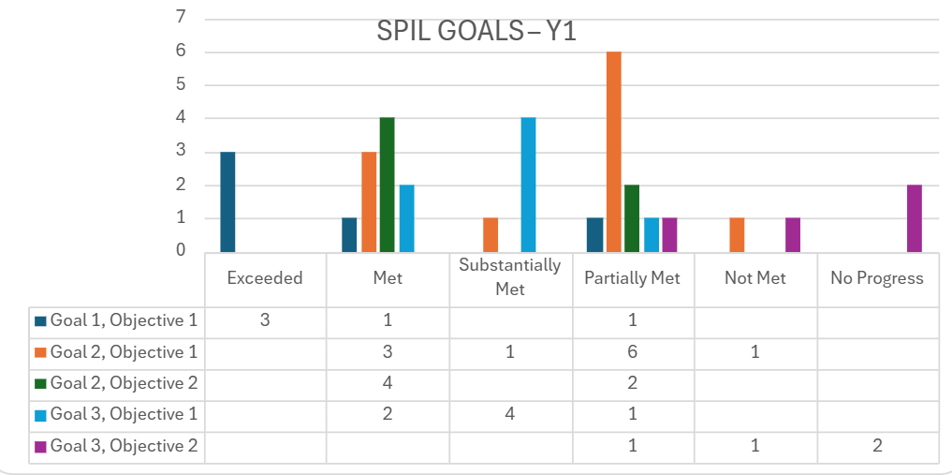

87.9% of Year 1 indicators show positive progress with 29 of 33 measurable indicators having been at least partially met. 54.5% of the indicators are exceeded, met, or substantially met.

Alt text: Bar chart titled “SPIL GOALS – Y1” showing counts of outcomes (Exceeded, Met, Substantially Met, Partially Met, Not Met, No Progress) for five goal/objective areas. Goal 1 Objective 1: Exceeded 3, Met 1, Partially Met 1. Goal 2 Objective 1: Met 3, Substantially Met 1, Partially Met 6, Not Met 1. Goal 2 Objective 2: Met 4, Partially Met 2. Goal 3 Objective 1: Met 2, Substantially Met 4, Partially Met 1. Goal 3 Objective 2: Partially Met 1, Not Met 1, No Progress 2.
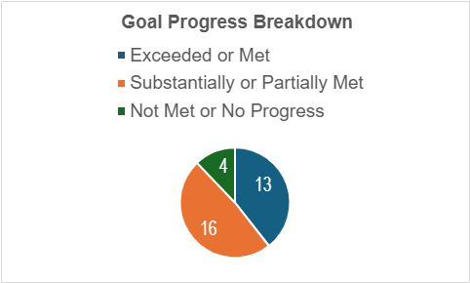
Alt text: Pie chart titled “Goal Progress Breakdown” with three categories: Exceeded or Met: 13. Substantially or Partially Met: 16 (largest section). Not Met or No Progress: 4 (smallest section).

Indicator Detail
Complete goal, objective and indicator language are available in the complete SPIL document linked above.

Goal 1: Strengthen the Indiana Independent Living Network and increase resource capacity

Objective 1: Secure additional funding to support and expand the Network
Indicator Status | Count | Percent
Met or exceeded | 4 of 5 | 80%
Partially met | 1 of 5 | 20%
Not met | 0 of 5 | 0%

Partially Met Indicator Remediation Plan:
- 1.1.6 – Network Resource Capacity Assessment:
Status: 50% complete; Key findings: Network needs support in fundraising, marketing, and alternative housing resources; Action underway: Fundraising workgroup is being convened; first meeting scheduled by April 30, 2026

Goal 2: Increase community capacity to support the Independent Living Network and promote the Independent Living Philosophy statewide

Objective 1: Educate the community on issues impacting people with disabilities to increase awareness and improve outcomes
Indicator Status | Count | Percent
Met or Substantially Met | 4 of 11 | 36.4%
Partially met | 6 of 11 | 54.5%
Not met | 1 of 11 | 9.1%

Partially Met / Not Met Indicators Remediation Plans:
- 2.1.3 / 2.1.11 – Network Conference: Last held in 2024; not feasible in 2025 due to economic uncertainty. Next conference set for Sept 29–30, 2026; INSILC + Independence Indiana planning underway.
- 2.1.4 & 2.1.8 – Consumer Needs Assessment: Add qualitative data via focus groups in 2026. SPIL Committee to approve Focus Group Workgroup in Feb 2026; meetings start Mar 2026; groups run Summer 2026 (youth, veterans, racial/ethnic minorities, rural residents).
- 2.1.5 – Leadership Representation (+5% target): CIL outreach begins Feb 2026 to map governance structures, leadership pipelines, board composition, and succession planning; goal is to identify barriers and promising practices.
- 2.1.7 – Annual Position Paper: Clarified scope to align with IL philosophy; renamed to “Alternatives to Guardianship Workgroup.” NCIL Guardianship Position Statement to go to full Council for vote on Mar 11, 2026.
- 2.1.9 – Not Met (Event Surveys): Network lacked a method in Year 1. As of Jan 2026, INSILC added the measure to its general survey; CIL conversations begin Feb 2026 to integrate this field into existing tools.

Objective 2: Gather input from people with disabilities and strengthen peer-to-peer mentorship to elevate their voices statewide
Indicator Status | Count | Percent
Met or Substantially Met | 4 of 6 | 66.6%
Partially met | 2 of 6 | 33.3%
Not met | 0 of 6 | 0%

Partially Met Indicators Remediation Plans:
- 2.2.2 – SPIL in Plain Language & Accessible Formats -- The SPIL Committee is currently reviewing proposals from plain language specialists. Final selection will be made at the May 18, 2026 SPIL Public Meeting. The accessible, plain language versions will cover both the 2025–2027 SPIL and 2027–2030 SPIL.
- 2.2.6 – Years 1–3 Consumer Needs Assessment -- The Data Analysis Workgroup recommended to the SPIL Committee that more qualitative data is needed. A new Focus Group Workgroup will be approved in February 2026. Planning begins spring 2026; meetings start March 2026. Focus groups will occur Summer 2026, targeting: youth, veterans, racial/ethnic minorities, and rural residents.

Goal 3: Promote and advocate for full inclusion of people with disabilities in all aspects of community life

Objective 1: Collaborate across the Independent Living Network to reduce barriers and increase awareness of Independent Living Philosophy and the role of Centers for Independent Living
Indicator Status | Count | Percent
Met or Substantially Met | 6 of 7 | 85.7%
Partially met | 1 of 7 | 14.3%
Not met | 0 of 7 | 0%

Partially Met Indicator Remediation Plan:
- 3.1.8 – Strategic Plan for Collaboration -- INSILC collaborated with disability-focused organizations throughout Year 1, including local Centers for Independent Living. However, these efforts were not guided by a formal strategic plan as required. As of January 2026, INSILC is reviewing proposals from strategic planning consultants. A facilitator will be approved at the March 11, 2026 Council meeting, with strategic planning work beginning April 2026.

Goal 3: Promote full inclusion of people with disabilities in the mainstream of society

Objective 2: Model strategic, cross disability systems change through responsive, innovative practices
Indicator Status | Count | Percent
Met or Substantially Met | 0 of 4 | 0%
Partially met | 1 of 4 | 25%
Not met or No Progress | 3 of 4 | 75%
Partially Met Indicator & Remediation Plans:
- 3.2.5 – Self-Advocacy Curriculum Collaboration -- In 2025, INSILC partnered with The League to host an Accessible Transportation Symposium, which included a self advocacy component. A second symposium is scheduled for June 3, 2026 in Columbus, IN. Expanded collaboration across the Network is planned in 2026 to develop and host additional self advocacy programming. INSILC will begin conversations with CILs in February 2026 to coordinate these efforts.
Indicators Not Met / No Progress Indicator Remediation Plans:
- 3.2.1 – Emergency Preparedness Committee -- INSILC formed an Emergency Preparedness Workgroup in December 2025. Membership approvals scheduled for the February 16, 2026 SPIL meeting. Meetings will begin March 2026.
- 3.2.2 – Annual Community Engagement Report -- Because the Network is adding focus group data in 2026, no report was issued in 2025. The Focus Group Workgroup will be approved in February 2026. Focus groups begin Summer 2026. Goal: Publish the Community Engagement Report by end of 2026.
- 3.2.4 – Healthcare Provider Resource Package -- A Healthcare Workgroup was formed as of January 2026; membership development is ongoing. Workgroup approval at the February 16, 2026 SPIL Committee meeting. Meetings begin March 2026.

