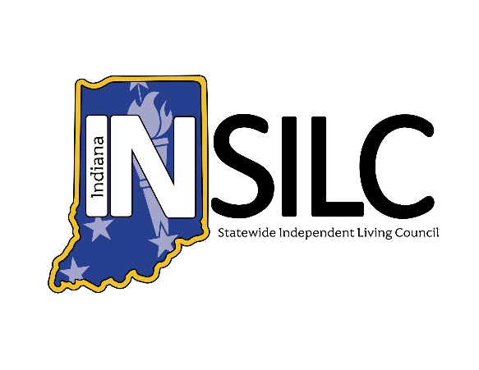

INSILC Public Meeting Agenda
March 11, 2026

Meeting information:
Date: Wednesday – March 11, 2026
Set Up/Accessibility Checks: 1:45 p.m. – 2:00 p.m. EDT
Meeting Time: 2:00 p.m. – 4:00 p.m. EDT
Meeting Type: Public Hybrid Webinar
Description: INSILC March Public Meeting. Open to the Public.
In-Person Location: Embassy Suites by Hilton Noblesville Indianapolis Conference Center
13700 Conference Center Drive South, Noblesville, IN 46060
Platform: Zoom and in Person
Join from a PC, Mac, iPad, iPhone or Android device:
https://zoom.us/j/95724102735?pwd=Jjhrsy4cXxJ5MS7ZuYaSZSvgsRSi5X.1
Or One tap mobile:
+13126266799, 98910248145# US (Chicago)
INSILC Public Meeting Agenda:

Call to Order/Open Meeting & Welcome – INSILC Chair, Kacie Weldy

Roll Call – INSILC Chair, Kacie Weldy
- Voting Members:
- Kacie Weldy, Chair
- Luis Roman, Vice-Chair
- Anna Thompson-Jones, Treasurer
- Jennifer David, Secretary
- Amy Browning-Varble, CIL Director Representative
- Ann Barnhart, Council Member
- Halie Brown, Council Member
- Linda Greeno, Council Member
- Laura Kitterman, Council Member
- Gary Olsen, Council Member
- Christina Trimnell, Council Member
- Catherine Vest, Council Member
- Dave Schleppenbach, Council Member

- Non-Voting Members:
- Amy Luellen, FSSA/DSE Representative

- Guest Attendees
- Mike Foddrill Jr, INSILC Executive Director
- Chris Spinks, SPIL Committee Chair
- Katy Myers, INSILC Operations Manager
- Danielle Bradley – New Council Nominee

Statement of Accessibility & Means for resolution of access concerns – INSILC Director, Mike Foddrill
Please reach out to Mike Foddrill INSILC Executive Director with any access concerns
Email: MFoddrill@indianasilc.org
Phone: 317-514-6145

Confirmation of Quorum – INSILC Secretary, Jennifer David
Total No. of appointed Council Members: 14
No. Council Members Present:
No. Voting Members Present:
Percentage of Voting Members: %

Has meeting attained Quorum:

Approval of Minutes – INSILC Chair, Kacie Weldy
December 10, 2025, Public Meeting Minutes*
January 21, 2026, Special Session Minutes*

Ongoing Communications – INSILC Secretary, Jennifer David

Upcoming Public Meetings – Fiscal Year 2026
      - Meeting Day: Wednesday
      - Meeting Time: 2:00 p.m.- 4:00 p.m. EDT (new time)
      - Upcoming Dates:
- June 10, 2026
- September 9, 2026
- December 9, 2026

Hybrid Meeting Goal

Acknowledge first public meeting. Location for the next meeting will be announced soon.

Notice of Communication Rules for Public INSILC Meetings:
    - Announcement of speaker’s time limit.
    - Meeting facilitator
      - Will state when the time limit has ended
      - Will then mute the speaker.
    - Additional comments not received in the meeting can be received in various other methods, which can be found at this link: https://insilc.org/feedback/
    - Identify oneself before speaking and speak in normal tone and speed for interpreting accessibility.

Public Comment – Open for 15 Minutes
- Any feedback not given at the public meeting can be received in multiple formats, get more information at https://insilc.org/feedback/.
- View INSILC's policy on Public Participation and Comment in Public Meetings on page 12 of the Public Facing Policies Document located at the bottom of the About page on the INSILC website.

Committee & State Updates, Reports, Comments –
  - INSILC Executive Director – Mike Foddrill
  - INSILC Treasurer Report – Anna Thompson–Jones
  - CIL Director Representative Report – Amy Browning-Varble
    - Traci Taylor – Independent Living Center of Eastern Indianna (ILCEIN)
    - Becky Anderson - ATTIC
  - Designated State Entity (DSE) Report – Amy Luellen
  - INSILC SPIL Committee Report – Chris Spinks
  - INSILC Nominations Committee Report – Mike Foddrill

Old Business –
  - SPIL/CAP Status – Mike Foddrill
  - Strategic Plan Discussion – Mike Foddrill

New Business –
  - New Council Member Nominee* - Mike Foddrill
  - NCIL Guardianship Statement Approval* - Mike Foddrill
  - SPIL Year 1 Report* – Chris Spinks
  - SPIL Dashboard (New Format) Approval* – Mike Foddrill
  - accessABILITY Emergency Preparedness Proposal* – Mike Foddrill
  - Inclusion Institute sponsorship Proposal* – Mike Foddrill
  - Strategic Plan Discussion – Mike Foddrill

Public Comment – Opened for 15 Minutes
- Any feedback not given at the public meeting can be received in multiple formats, get more information at https://insilc.org/feedback/.
- View INSILC's policy on Public Participation and Comment in Public Meetings on page 12 of the Public Facing Policies Document located at the bottom of the About page on the INSILC website.

Adjournment

Do you need accommodations for this meeting?
For INSILC meetings and other INSILC-related event accommodation requests, please contact:
Email: info@indianasilc.org
Accommodation requests should be made at least two business days in advance to help to ensure the availability of the accommodation.
ASL Interpretation and CART (Live Captioning) will be present during the public meeting.

Glossary of Abbreviations:
INSILC – Indiana Statewide Independent Living Council
ASL – American Sign Language
CIL – Centers for Independent Living
DSE – Designated State Entity
FSSA – Family Social Services Agency
SPIL – Statewide Plan for Independent Living
FY – Fiscal Year

