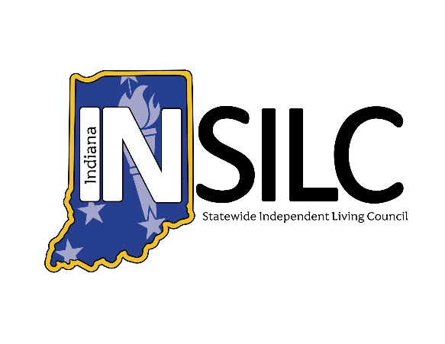

INSILC Special Session Meeting Agenda
January 21, 2026

Meeting information:
Date: Wednesday – January 21, 2026
Set Up/Accessibility Checks: 12:45 p.m. – 1:00 p.m. EDT
Meeting Time: 1:00 p.m. – 1:30 p.m. EDT
Meeting Type: Public Webinar
Description: INSILC Special Session Meeting. Open to the Public.

Platform: Zoom
Join from a PC, Mac, iPad, iPhone or Android device:
https://zoom.us/j/95724102735?pwd=Jjhrsy4cXxJ5MS7ZuYaSZSvgsRSi5X.1
Or One tap mobile:
+13126266799, 98910248145# US (Chicago)
+16465588656, 98910248145# US (New York)

INSILC Special Session Agenda:

Call to Order/Open Meeting & Welcome – INSILC Chair, Kacie Weldy

Roll Call – INSILC Chair, Kacie Weldy
- Voting Members:
- Kacie Weldy, Chair
- Luis Roman, Vice-Chair
- Anna Thompson-Jones, Treasurer
- Jennifer David, Secretary
- Amy Browning-Varble, CIL Director Representative
- Ann Barnhart, Council Member
- Halie Brown, Council Member
- Linda Greeno, Council Member
- Laura Kitterman, Council Member
- Gary Olsen, Council Member
- Christina Trimnell, Council Member
- Catherine Vest, Council Member
- Dave Schleppenbach, Council Member

- Non-Voting Members:
- Amy Luellen, FSSA/DSE Representative

- Guest Attendees
- Mike Foddrill Jr, INSILC Executive Director
- Chris Spinks, SPIL Committee Chair

Statement of Accessibility & Means for resolution of access concerns – INSILC Director, Mike Foddrill
Please reach out to Mike Foddrill INSILC Executive Director with any access concerns
Email: MFoddrill@indianasilc.org
Phone: 317-514-6145

Confirmation of Quorum – INSILC Secretary, Jennifer David
Total No. of appointed Council Members:
No. Council Members Present:
No. Voting Members Present:
Percentage of Voting Members: %

Has meeting attained Quorum:

Approval of FY25 PPR – INSILC Chair, Kacie Weldy

Adjournment

Do you need accommodations for this meeting?
For INSILC meetings and other INSILC-related event accommodation requests, please contact:
Email: info@indianasilc.org
Accommodation requests should be made at least two business days in advance to help to ensure the availability of the accommodation.
ASL Interpretation and CART (Live Captioning) will be present during the public meeting.

Glossary of Abbreviations:
INSILC – Indiana Statewide Independent Living Council
ASL – American Sign Language
CIL – Centers for Independent Living
DSE – Designated State Entity
FSSA – Family Social Services Agency
SPIL – Statewide Plan for Independent Living
FY – Fiscal Year

