INSILC 2019-2023 SPIL EVALUATION REPORT

June 30, 2024

Contents
2021-2023 State Plan for Independent Living (SPIL) Overview and Comments 4
Background 4
Report Details 4
SPIL Goals and Objectives Overview 4
Evaluation Process Challenges 6
Evaluation Rating Scale 6
2021-2023 SPIL Goal Overall Summary 7
Goal 1 Overall Summary: Partially Met 7
Goal 2 Overall Summary: Partially Met 7
Goal 3 Overall Summary—No Progress 7
SPIL Goals Overall Summary 7
Discussion of Goal 1: Build Resource Capacity of the IL Network 9
Objective 1A: Develop Alternative Funding Sources to expand IL Network Opportunities 9
Objective 1B: Secure additional funding to support the IL Network 13
Objective 1C: The IL Network will create a plan for the expansion of services and statewide expansion as appropriate. 15
Goal 2: Community Capacity Increased to Support the IL Network and Promote IL Philosophy throughout the State 17
Objective 2A: Hoosiers will better understand the needs and barriers of individuals with disabilities through community education efforts—with specific emphasis on PWD who are multiply marginalized. 17
Objective 2B: Gather input on the needs of PWD in Indiana—from PWD. 20
Goal 3: The Indiana IL Network will promote and advocate for the integration and full inclusion of individuals with disabilities into the mainstream of American society. (Systems Advocacy) 22
Objective 3A: Conducted grassroots advocacy for systemic change. 22
Objective 3B: IL Network conducts outreach to PWD to engage in the public policy process. 22
Objective 3C: The IL Network will amplify the voice of PWD in improving the availability of housing, transportation and health care. 24
Consumer Satisfaction 25
Recommendations 25
Appendices 26
Goal 1—Objective 1-A Detail 26
Goal 1—Objective 1-B Detail: 27
Goal 1—Objective 1-C Detail: 28
Goal 2—Objective 2A Detail: 29
Goal 2—Objective 2-B Detail: 30
Goal 3—Objective 3-A Detail: 31
Goal 3—Objective 3-B Detail: 32
Goal 3—Objective 3-C Detail: 33

2021-2023 State Plan for Independent Living (SPIL) Overview and Comments

Background
The Indiana Statewide Independent Living Council’s (INSILC) SPIL Committee’s job was to conduct on-going monitoring of all projects supported by the Council and the Statewide Plan, and to conduct the evaluation at the end of each year.

The SPIL Committee created an evaluation process and began work in 2020. Subsequent events prevented the SPIL Committee from continuing its work. As a result, no active evaluation of the SPIL has occurred before the creation of this report.

In December of 2022, INSILC, under new leadership, began the process of reengaging with the critical work of the SPIL. This evaluation report is the work of the Executive Committee of the SILC. The newly reformed SPIL Committee is currently working on the next SPIL for FY25-27. The evaluation process for the new SPIL will begin immediately upon approval of the SPIL by ACL.

Report Details
This evaluation report covers the activities from October 1, 2018 (to show prior SPIL baseline), through September 30, 2023, and is related to the objectives of the Indiana Statewide Plan for Independent Living (SPIL). This plan has received an extension for one additional year and will end on September 30, 2024.

This plan has 3 goals, 8 objectives and 43 measurable indicators.

This report covers the activities of the Indiana Independent Living Network which consists of Centers for Independent Living (CILs), the Indiana Statewide Independent Living Council (INSILC) and the Indiana Family and Social Services Administration which serves as Designated State Entity (DSE).

This report utilizes data provided by the IL Network through individual and collective Program Performance Reports (PPR), monitoring reports and other documentation.

SPIL Goals and Objectives Overview
As stated in the SPIL the mission of the Indiana IL Network, and the 3-year SPIL for 2021-2023 is:
Self-determination and full inclusion of people with disabilities through the Independent Living Philosophy.

Goals
The SPIL contains three specific goals to achieve progress toward the mission:

- The Indiana IL Network will work to strengthen the network and increase resource capacity. (Build Resource Capacity of the IL Network)
- Community Capacity Increased to Support the IL Network and Promote IL Philosophy throughout the State
- The Indiana IL Network will promote and advocate for the integration and full inclusion of individuals with disabilities into the mainstream of American society. (Systems Advocacy)

Each goal has two or three objectives, and each objective has measurable indicators and targets to measure success. These indicators were selected to show that if these were met, it would indicate that the broader objectives were also met.

In addition to the identified goals, the SPIL Evaluation must also address the effectiveness of the plan in meeting the satisfaction of individuals with disabilities through the use of consumer satisfaction survey reports.

Objectives and Measurable Indicators
The SPIL objectives are broad statements, like the goals and are not measurable. The desired changes are found in the measurable indicators. There are 43 measurable indicators in the SPIL.

Sometimes people confuse outputs with desired outcomes. If the statement is about a program, it is an output (like how hard the program is working). However, if the statement is saying something about the people you are trying to benefit, then it is an outcome. To be more specific, it is a desired outcome; the goal of your efforts.

Examples of these four essential components:

Measurable indicators are the data points that tell us we are achieving our goals. We do not technically “measure” outcomes. Instead, we measure indicators of outcomes. Measurable indicators are the specific items of information that signal a program’s success in achieving an outcome. Another way of looking at indicators is they are the specific information collected to track a program’s success on an outcome.

Evaluation Process Challenges
The evaluation process created in 2020 implemented quarterly reporting on SPIL accomplishments. Using a newly implemented quarterly payment system created in coordination with our DSE, CILs were able to submit reports that supported the gathering of data relative to SPIL goal indicators.

These reports were utilized in FY21 and FY22 and the data gathered is utilized in creating this report.

It was clear from the beginning that the tools created for reporting were overly complicated. Additionally, feedback from CIL Directors informed the SILC that the information requested was difficult to gather using the tools available and was not aligned with how CILs gather data. The DSE, in consultation with the CIL Directors and the SILC, elected to stop using the SPIL goal indicator reporting tools at the end of FY22. Subsequent events prevented the SPIL Committee from creating a new evaluation process for FY23.

In December of 2022 INSILC discovered that critical data had been deleted from Council servers. Upon the advice of legal counsel, the Council pursued all applicable remedies to recover the data. The Council’s efforts to restore or reconstruct its critical data have been largely successful. Unfortunately, there are gaps in information related to the specific activities of the SILC’s staff. These gaps make reporting challenging for some of the measurable indicators as they relate to SILC activities.

The consequence of these evaluation challenges is that this report will underrepresent the efforts and accomplishments of the IL Network for this three-year period.

Evaluation Rating Scale
This report uses an evaluation rating scale that ranges from a high of “exceeding” the target to a low of the target was “not met”.

- Exceeded—a target was exceeded.
- Met—a target was met exactly.
- Substantially Met—greater than 60% and less than 100% of the target was achieved.
- Partially Met—greater than 0 but less than 60% was achieved.
- Not Met—nothing was achieved.
- No Progress—the target was delayed or not started.

2021-2023 SPIL Goal Overall Summary

Goal 1 Overall Summary: Partially Met
Goal 1 was Partially Met as 4 out of 16 indicators were met or exceeded (25.00%)

- Objective A
- 3 of 5 indicators met or exceeded (60%)
- 1 of 5 indicators partially met (20%)
- 1 of 5 indicators with No Progress (20%)
- Objective B
  - 1 of 9 indicators met or exceeded (11.11%)
  - 1 of 9 indicators partially met (11.11%)
  - 1 of 9 indicators not met (11.11%)
  - 6 of 9 indicators with No Progress (66.67%)
- Objective C
  - 0 of 2 indicators met or exceeded (0%)
  - 2 of 2 indicators with No Progress (100%)

Goal 2 Overall Summary: Partially Met
Goal 2 was Partially Met as 7 out of 15 indicators were met or exceeded (46.67%)

- Objective A
- 4 of 11 indicators met or exceeded (36.36%)
- 7 of 11 indicators with No Progress (63.64%)
- Objective B
  - 3 of 4 indicators were met or exceeded (75%)
  - 1 of 4 indicators with No Progress (25%)

Goal 3 Overall Summary—No Progress
Goal 3 had No Progress as 0 out of 11 indicators were met or exceeded (0%)

- Objective A
- 0 of 2 indicators met or exceeded (0%)
- 2 of 2 indicators with No Progress (100%)
- Objective B
  - 0 of 5 indicators met or exceeded (0%)
  - 1 of 5 indicators partially met (20%)
  - 4 of 5 indicators with No Progress (80%)
- Objective C
  - 0 of 4 indicators met or exceeded (0%)
  - 4 of 4 indicators with No Progress (100%)

SPIL Goals Overall Summary
Evaluated as a pool, 10 of 42 measurable indicators (23.81%) were exceeded or met, so the overall SPIL was Partially Met. Looking another way, 13 of the 42 measurable indicators (31%) had at least some measurable progress.
We are disappointed to report that so few SPIL objectives were met—67% of the objectives had no progress made in three years. Our analysis indicates that several factors contributed to this outcome, including:
- Breakdown in communication between the SILC’s former Executive Director and the rest of the IL Network
- Indicators identified did not accurately measure desired outcomes
- Indicators that had no methodology for measurement
- Impact of COVID-19 on everyone
- Lack of executive leadership at the SILC

To prevent a similar situation in the future, the SILC implemented the following measures:
- The hiring of a new Executive Director
- The creation of a new SPIL Committee dedicated to elevating the voices of more people with disabilities.
- The integration of 9 new SILC council members.
- The commitment of the majority of the IL Network to being a part of the solution moving forward through increased collaboration.

The SILC views this experience as a valuable learning opportunity. By carefully analyzing these results, we can enhance our management processes and increase our chances of success in the next SPIL.

The table below shows the results for each of the 3 goals:
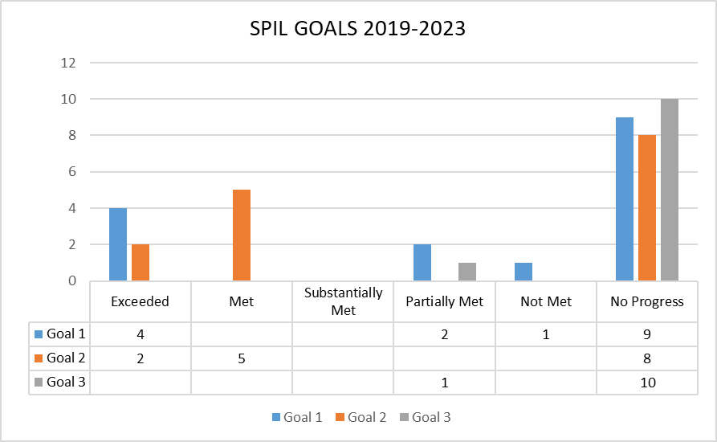

Discussion of Goal 1: Build Resource Capacity of the IL Network

Objective 1A: Develop Alternative Funding Sources to expand IL Network Opportunities
There were 5 measurable indicators related to Objective A. Of these, 3 were exceeded, 1 was partially met, and 1 had no progress. The objective overall was Partially Met, as 60% of the indicator targets were met or exceeded.

Objective A focused on increasing the capacity and infrastructure of the IL Network to increase the independence of people with disabilities through increased services, programs, and community activities.

Additionally, the objective sought to create IL Network wide standards for service delivery and to explore alternative methods of service delivery for consumers.

The measurable indicators looked at:
- The amount of other funding available to the network.
- The number of services provided to consumers.
- The number of community activities.
- Resource development.
- Consumers receive services in non-traditional manners.

Indicator 1: PPR funding report shows a 2% increase annually in other funding.

Measurable Indicator Measurement: PPR Private Resources 1.1.3 and Quarter 2 Deliverable Report

Result: Exceeded

ACL tracks the following categories of Other Funding called Private Resources in section 1.1.3 of the Program Performance Report (PPR):
- Foundations, Corporations or Trust Grants
- Donations from Individuals
- Membership Fees
- Investment Income/Endowment
- Fees for Service (program income, etc.)
- Other resources (in-kind, fundraising, etc.)

The Indiana Independent Living Network showed year-over-year gains averaging 18.71% FY18 to FY23. Individually four (4) Agencies showed gains and eight (8) showed decreases over the total period. The variance runs from $0 to $2,392,175 in other funding in FY23 as seen in the chart below.

Ongoing efforts to support agencies to increase other funding should continue.

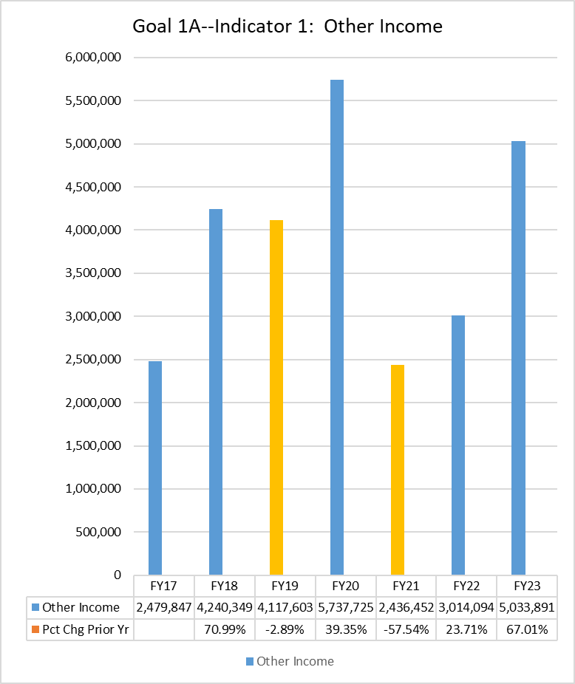

Indicator 2: PPR services report shows a 2% increase annually in services provided.

Measurable Indicator Measurement: PPR Services 4.1

Result: Exceeded

Total services showed year-over-year gains FY18 to FY23 of 73.15%.

Note: The impact of additional one-time Part C CARES Act (COVID-19) funding positively impacted service delivery.

Significant increases in service provision occurred within the network. The greatest contributor to this increase was the CARES Act funding of $1,444,870 received by six (6) Part C centers in FY20 and FY21. These funds were one-time, non-repeating funds.

Significant increases in services occurred for the following:

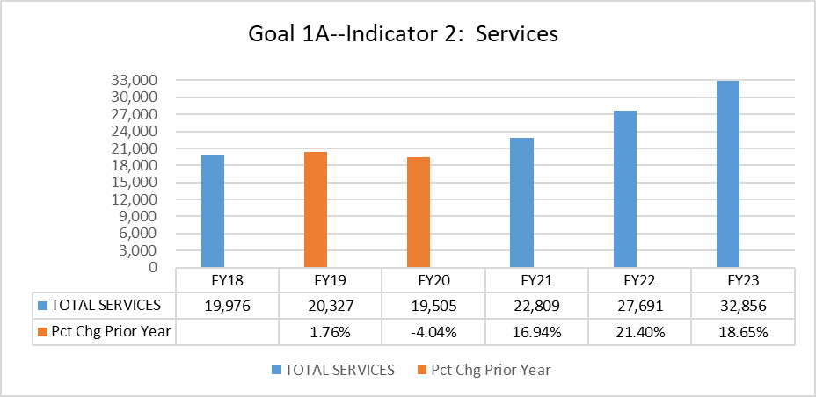

Indicator 3: PPR community activities report shows a 2% increase annually.

Measurable Indicator Measurement: PPR Community Activities 5.6 and Quarter 2 Deliverables Report

Result: Partially Met

Hours of community activities decreased 21.96% year-over-year for the period FY18 to FY23. There was a rebounding of activities from FY22 to FY23 with a 22.9% increase. Additionally, COVID-19 impacted year over year community activities numbers.

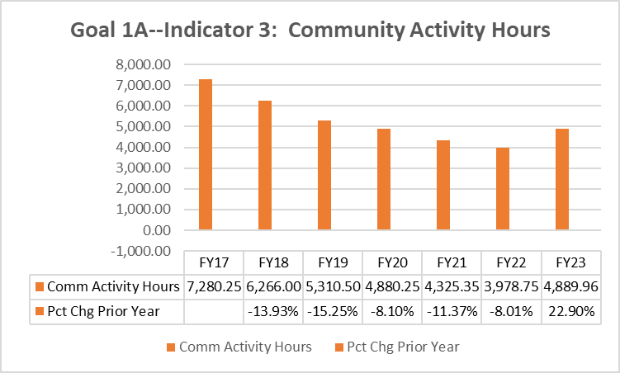

Indicator 4: Investment in resource development i.e., strategic planning training, development of measurable outcomes, grant writing training/support, fee for service development and revenue diversification, focus on building collaborations and partnerships increases by 5%.

Measurable Indicator Measurement: Unknown

Result: No Progress

During the SPIL period FY18-FY23 no methodology was created to track this indicator

Indicator 5: Number of consumers receiving services in non-traditional manners increased by 5%

Measurable Indicator Measurement: Goal 1-A Deliverables Report

Result: Exceeded

The Deliverables tool defined the following:
- Traditional methods of service delivery include but are not limited to: In-person meetings and telephone calls.
- Non-traditional methods of service delivery would be services delivered that are not the above. Given the COVID-19 pandemic, we realize that most of your services will be non-traditional manner.

This indicator was only tracked from FY20 to FY22. The tracking of this data reflects the impact of the COVID-19 pandemic on the IL Network. Year-over-year gains averaged 78.07% with a high of 2,066 non-traditionally provided services in FY21 to a low of 618 in FY20.

Objective 1B: Secure additional funding to support the IL Network
There were 9 measurable indicators related to Objective B. Of these, 1 was exceeded, 1 was partially met, 1 was not met and 6 had no progress. The objective overall was Partially Met, as 22% of the indicator targets were met or exceeded.

Objective B focused on increasing the operational capacity and sustainability of the IL Network to increase the independence of people with disabilities through increased funding.

Additionally, the objective sought to research, create and implement an improved funding formula.

The measurable indicators looked at:
- The amount of state funding available to the network.
- The number of services provided to consumers.
- The number of community activities.
- The number of community activities involving elected officials and/or policy makers.
- Assessing the needs of the IL Network to determine additional resources needed to reach minimum operating efficiency.
- Achieving base minimum funding and compliance within the IL Network.
- Creating a new funding formula

Indicator 1: PPR funding shows a 2% increase annually in state funding.

Measurable Indicator Measurement: PPR Funding Section 1.1.2 State Government Funds

Result: Not Met

State funding year-over-year has shown a gain of only 0.43% from FY18 to FY23. There was a significant reduction in FY20 of 15% that was recovered in FY22.

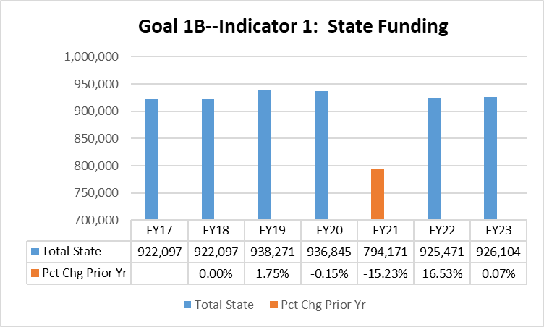

Indicator 2: PPR services report shows a 2% increase annually in services provided

Measurable Indicator Measurement: PPR Services 4.1 and Quarter 1 Deliverables Report

Result: Exceeded

See data from: Goal 1-A—Indicator 2

Indicator 3: PPR community activities report shows a 2% increase annually.

Measurable Indicator Measurement: PPR Private Resources 1.1.3 and Quarter 1 Deliverables Report

Result: Partially Met

See data from: Goal 1-A—Indicator 3

Indicator 4: PPR community activities involving elected officials, legislative staffers and/or policy makers increase by 3%

Measurable Indicator Measurement: PPR Community Activities 5.6

Result: No Progress

It is not possible to identify the number of hours of activities related to this indicator.

Indicator 5 and 6: By Year 2—Centers will have the tools and resources to demonstrate compliance and receive assistance as needed. And--By Year 3, all Centers will maintain base minimum funding and demonstrate compliance.

Measurable Indicator Measurement: PPR Community Activities 5.6

Result: No Progress

The intent of this indicator is to show that by reaching base level funding agencies would increase operating capacity and efficiency.

No agency in the network is receiving sufficient Title VII, Part C funding to reach the SPIL identified base level of $756,467 (adjusted for inflation from 2012 data of $570,000).

Additionally, the SILC did not implement a needs assessment for the IL Network to determine additional resource needs.

Indicator 7, 8, and 9: By end of Year 1—improved funding formula researched, By end of Year 2—improved funding formula created, and By end of Year 3—improved funding formula implemented

Measurable Indicator Measurement: Funding Formula

Result: No Progress

No activities were conducted towards this indicator.

Objective 1C: The IL Network will create a plan for the expansion of services and statewide expansion as appropriate.
There were 2 measurable indicators related to Objective C. Of these, 2 had no progress. The objective overall was No Progress, as 0% of the indicator targets were met or exceeded.

Objective C focused on achieving full statewide availability of IL Services.

Additionally, the objective sought to create a process to identify the location of potential new Centers, mechanisms to expand services in existing Centers, and the feasibility of Satellite offices.

The measurable indicators looked at:
- Creating a plan to determine the cost and most effective methodology to expand services.
- Expanding services by 5%

Indicator 1: Statewide plan for expansion established that determines the cost and most effective methodology.

Measurable Indicator Measurement: Expansion Plan

Result: No Progress

No actions taken on this indicator.

Indicator 2: Expansion of services by 5%

Measurable Indicator Measurement: PPR Services 4.1

Result: No Progress

While data results for services show a significant increase in service provision, none of those services were a result of efforts to expand the IL Network. It would be disingenuous to show this indicator as met.

Goal 2: Community Capacity Increased to Support the IL Network and Promote IL Philosophy throughout the State

Objective 2A: Hoosiers will better understand the needs and barriers of individuals with disabilities through community education efforts—with specific emphasis on people with disabilities (PWD) who are multiply marginalized.
There were 11 measurable indicators related to Objective A. Of these, 2 were exceeded, 2 were met and 7 had no progress. The objective overall was Partially Met, as 36.36% of the indicator targets were met or exceeded.

Objective A focused on the IL Network regularly engaging in activities aimed at educating the community on topics that impact the disability community, general disability awareness, and other training topics. .

Additionally, the objective sought to create a collective outcome across the entire state through a practice that developed common practices of evaluation.

Finally, the objective sought to ensure that CILs created activities most needed in their specific communities.

The measurable indicators looked at:
- On-going educational engagement
- Increased community activities
- Evaluation practices
- Impacting people with disabilities who are multiply marginalized (MM)
- Best practices

Indicator 1: On-going educational engagement reflected by PPR training report.

Measurable Indicator Measurement: Training Report

Result: No Progress

No assessment tool was created to measure this indicator.

Indicator 2: PPR community activities report shows a minimum of 50 activities with groups that are representative of people who are MM in year 1—increasing to 75 in year 2 and 100 in year 3

Measurable Indicator Measurement: Community Activities detail

Result: No Progress

The SPIL defined multiple marginalization as:

A convergence of social inequity and marginalization, such as racism, disability, poverty, religious persecution, sexism, ageism or homophobia, which produce unique vulnerabilities and social inequities.

No assessment tool was created to measure this indicator.

Indicator 3: Established and implemented evaluation practices across the network to use when measuring the impact of community education programs by March 2021

Measurable Indicator Measurement: Community Education Impact Report

Result: No Progress

No assessment tool was created to measure this indicator.

Indicators 4 and 5: Annual summary report on activities performed and overall evaluation measure reporting. Including recommendations for improvements—November. PWD who are MM are leading and directing decisions and policies that impact their lives.

Measurable Indicator Measurement: Activities Report on impact on multiply marginalized communities.

Result: No Progress

No assessment tool was created to measure this indicator.

Indicator 6: Decision-making staff who are PWD in the IL Network increases from 69% to 75%

Measurable Indicator Measurement: PPR 2.2 Compliance Indicator: Philosophy and Quarter 3 Deliverable Report

Result: Exceeded

Decision Making staff increased from FY18 at 68.55% to FY23 75.44%

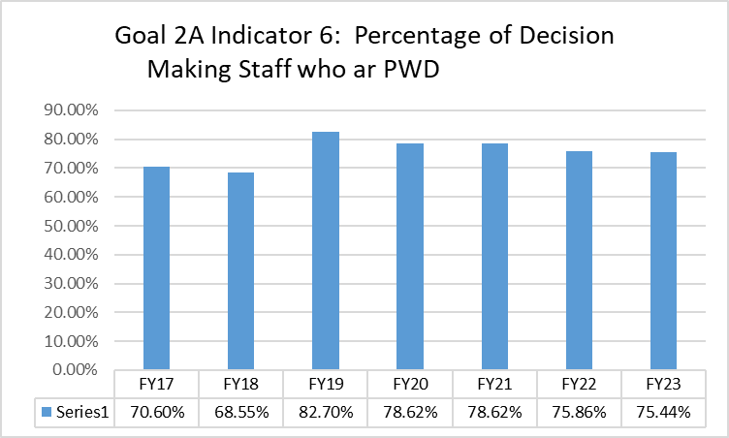

Indicator 7: Increased number of PWD who are MM serving on community boards, committees, etc. as measured by survey. Baseline is year 1.

Measurable Indicator Measurement: Survey

Result: No Progress

No survey was conducted.

Indicator 8: Decision-Making staff participate in a minimum of 8 hours of professional development related to improving outcomes for MM PWD annually.

Measurable Indicator Measurement: Goal 1-C Deliverable Report

Result: Exceeded

Training hours increased from 6 total hours in FY20 to 343 total hours in FY22. The target of 80 total hours was exceeded.

Note: Data tracked from FY20 through FY22. No new data was collected in FY23.

Indicator 9: Each ILN member conducts a minimum of 2 hours of training per year on the IL Philosophy for all staff and board members annually.

Measurable Indicator Measurement: Goal 1-C Deliverable Report

Result: Met

All reporting agencies provided a minimum of 2 hours of IL Philosophy training.

Indicator 10: IL Leadership will participate in 8 hours of best practices training annually.

Measurable Indicator Measurement: Goal 1-C Deliverable Report

Result: Met

Eight (8) CILs indicated that leadership participated in promising practices training each year.

Indicator 11: All training must be conducted by PWD.

Measurable Indicator Measurement: Goal 1-C Deliverable Report

Result: No Progress

No assessment tool was created to measure this indicator.

Objective 2B: Gather input on the needs of PWD in Indiana—from PWD.
There were 4 measurable indicators related to Objective B. Of these, 3 were met and 1 objective had no progress. The objective overall was Substantially Met, as 75.00% of the indicator targets were met or exceeded.

Objective B focused on increasing the awareness of CILs and the roles they can play in improving outcomes for PWD in Indiana.

The measurable indicators looked at:
- Collaborations and partnerships with groups that are representative of people who are multiply marginalized
- Increasing services to people who are multiply marginalized
- Conducting trainings and allyship events.

Indicator 1: PPR community activities report shows increased collaborations and partnerships with groups that are representative of people who are MM

Measurable Indicator Measurement: Goal 2-B Deliverable Report

Result: Met

Community activity hours with MM groups increased by 59.14% from FY20 through FY22. From a base of 97 to a final of 148.

Note: Data tracked from FY20 through FY22. No new data was collected in FY23.

Indicator 2: Increased participation of PWD who are MM as measured by the number of services provided—(any non-white, non-male, under the age of 65, and/or lives below the poverty line is MM)

Measurable Indicator Measurement: Goal 2-B Deliverable Report

Result: Met

Services to consumers identified as MM increased by 2.72% from FY20 through FY22. From a base of 2,896 to a final of 3,056.

Note: Data tracked from FY20 through FY22. No new data was collected in FY23.

Indicator 3: Conduct a minimum of 1 train the trainer allyship seminar annually.

Measurable Indicator Measurement: Training Report

Result: No Progress

The SILC does not have access to data related to any allyship seminars conducted by the SILCs previous administrator.

Indicator 4: Facilitate and/or Host an annual statewide allyship event.

Measurable Indicator Measurement: Training Report

Result: Met

A statewide Independence Indiana Conference was held in September 2023. This event brought CILs, advocates and partners together to learn together and further collaborate efforts.

Goal 3: The Indiana IL Network will promote and advocate for the integration and full inclusion of individuals with disabilities into the mainstream of American society. (Systems Advocacy)

Objective 3A: Conducted grassroots advocacy for systemic change.
There were 2 measurable indicators related to Objective A. Of these, 2 had no progress. The objective overall was No Progress, as 0.00% of the indicator targets were started.

Objective A focused on the IL Network increasing impact for PWD through alignment of other partners and an increased understanding of the IL Philosophy and the needs of PWD.

The measurable indicators looked at:
- People attending and providing comment at events
- Policies and practices within organizations reflect the desires of PWD.

Indicator 1: Number of people attending and providing comments at meetings or other events increases by 5% annually.

Measurable Indicator Measurement: Goal 2-B Deliverable Report

Result: No Progress

No collection methodology was created to facilitate the reporting of this indicator.

Indicator 2: Policies and practices within organizations reflect the desires of PWD. Follow-up survey of training and presentation attendees regarding impact and outcomes created.

Measurable Indicator Measurement: Survey

Result: No Progress

No collection methodology was created to facilitate the reporting of this indicator.

Objective 3B: IL Network conducts outreach to PWD to engage in the public policy process.
There were 5 measurable indicators related to Objective B. Of these, 1 indicator was partially met and 4 had no progress. The objective overall was Not Met, as 40.00% of the indicator targets were met or exceeded.

Objective B focused on the IL Network conducting outreach to PWD to engage in the public policy process.

The measurable indicators looked at:
- Consumer engagement
- Public comments
- Interactions with elected officials
- Increase in consumer interaction with elected officials.

Indicator 1: Survey consumers, increase engagement by 2% per year.

Measurable Indicator Measurement: Goal 3A to Goal 3C Report

Result: No Progress

No collection methodology was created to facilitate the reporting of this indicator.

Indicator 2: New consumer satisfaction survey questions address impact, ask if consumers wish to have more information on advocacy.

Measurable Indicator Measurement: Goal 3A to Goal 3C Report

Result: No Progress

No collection methodology was created to facilitate the reporting of this indicator.

Indicator 3: Number of people giving public comment during public committee hearing increases by 2% annually.

Measurable Indicator Measurement: Committee Reports

Result: No Progress

No collection methodology was created to facilitate the reporting of this indicator. Additionally, clarity on which committees were meant to be tracked was missing.

Indicator 4: IL Network members interact with their legislators (or staff), and achieve an 80% success rate.

Measurable Indicator Measurement: Goal 3A to Goal 3C Report

Result: Partially Met

There was an 80.67% increase in interaction with legislators from 61 in FY20 to 215 in FY22.

Notes:
- Data tracked from FY20 through FY22. No new data was collected in FY23.
- No collection methodology was created to facilitate reporting on the level of success in interactions
Indicator 5: Consumer surveys show a 2% increase in consumer direct advocacy with legislators

Measurable Indicator Measurement: Consumer Satisfaction Survey Report

Result: No Progress

A question addressing consumer direct advocacy with legislators was not added to the consumer survey tool.

Objective 3C: The IL Network will amplify the voice of PWD in improving the availability of housing, transportation and health care.
There were 4 measurable indicators related to Objective C. Of these, 4 indicators had no progress. The objective overall was No Progress, as 0.00% of the indicator targets were met or exceeded.

Objective C focused on the IL Network amplifying the voice of PWD in improving availability of housing, transportation and health care.

Additionally, the objective sought to increase systems advocacy by establishing annual priorities

The measurable indicators looked at:
- Legislative actions
- Number of accessible housing units
- Number of transportation options

Indicator 1: Number of positive legislative actions increased by 2% annually

Measurable Indicator Measurement: SILC Legislative action report

Result: No Progress

The SILC maintained the legislative action reports for the IL Network. All data related to those activities is unavailable to the current Council.

DSE did not require the gathering of this data.

Indicator 2: IL Network participation in action steps increased by 15%

Measurable Indicator Measurement: Policy Report

Result: No Progress

No data is available related to the policy report or action steps resulting from the report.

Indicator 3 and 4: Number of accessible housing units increases and number of transportation options increases

Measurable Indicator Measurement: Unknown

Result: No Progress

No data metrics were established for this indicator.

Consumer Satisfaction

Consumer satisfaction results are an important part of the collection of information to determine independent living needs of people with disabilities and to evaluate the effectiveness of the SPIL in meeting its objectives. Consumer feedback is a key mechanism to ensure that CILs are truly consumer controlled.

Each CIL in the state asks slightly different questions to reflect the information needed in their communities. It should be noted that some CILs survey consumers at varying points in the record cycle (beginning, mid-point and closed).

The data gathered from each CIL varied to such a degree that no statistical analysis is possible. Each reported high levels of consumer satisfaction either through data (consumer counts and percentages of satisfaction) or through written descriptions of their consumer survey process.

Recommendations
- Hire a consultant to refine the evaluation process.
  - Outcomes Management to improve the effectiveness of our programs and services and to communicate their value
  - Moving from activity-based measures to outcome measures
  - Outcomes selection to ensure we are capturing the best information
- Refine the indicators with concrete measurables.
  - Ensure indicators are equitable
  - Balance quantitative and qualitative indicators
- Create, train and support a separate Evaluation Committee
- Create a new evaluation rating scale
- Provide training on Outcomes Analysis to the IL Network and our communities
- Ensure information gathering is consistent and the process clearly understood
- Ensure data is properly analyzed
  - Clean the raw data
  - Analyze the data
- Create and implement a plan to USE the Outcome Information to improve the lives of our peers with disabilities.

Appendices

Goal 1—Objective 1-A Detail

Objective to be achieved | Desired Outcomes | Indicators
1.A). Develop Alternative Funding Sources to expand IL Network opportunities  The IL Network will undertake activities that lead to increased capacity and stronger infrastructure. | - IL Network gained resources to increase the independence of PWD through increased services and programs.  - IL Network gained resources to increase the number of services provided  - IL Network gained resources to increase community activities and systems advocacy efforts that ensure PWD’s are aware of their rights and can better effectively advocate on their own behalf  - Creation of IL Network wide standards for service delivery and reporting  - Exploration of non-traditional methods for service delivery | - PPR funding report shows a 2% increase annually in other funding  - PPR services report shows a 2% increase annually in services provided  - PPR community activities report shows a 2% increase annually.  - Investment in resource development i.e., strategic planning training, development of measurable outcomes, grant writing training/support, fee for service development and revenue diversification, focus on building collaborations and partnerships increases by 5%  - Number of consumers receiving services in non-traditional manners increased by 5%

Goal 1—Objective 1-B Detail:

Objective to be achieved | Desired Outcomes | Indicators
1. B) Secure additional funding to support the IL Network  Centers will have equity in funding levels to achieve minimum operating capacity and efficiency.  Currently, not all Centers have enough IL funds to achieve the base level of funds needed for Center Operations. The lack of equity in funds and base funds being met for all CILs creates operational capacity and sustainability issues, as well as inability to effectively serve their community. | - IL Network gained resources to increase the independence of PWD through increased services and programs.  - IL Network gained resources to increase the number of services provided  - IL Network gained resources to increase community activities and systems advocacy efforts that ensure PWD’s are aware of their rights and can better effectively advocate on their own behalf  - IL Network gained a leading voice at the statehouse  - Assess the current needs of the IL Network and determine the additional resources needed to reach minimum operating efficiency and identify the needs that still exist in the Network  - Research, create and implement an improved funding formula based on disparate impacts of population, race/ethnicity and other critical factors. | - PPR funding report shows a 2% increase annually in state funding  - PPR services report shows a 2% increase annually in services provided  - PPR community activities report shows a 2% increase annually.  - PPR community activities involving elected officials, legislative staffers and/or policy makers increase by 3%  - By Year 2—Centers will have the tools and resources to demonstrate compliance and receive assistance as needed  - By Year 3, all Centers will maintain base minimum funding and demonstrate compliance  - By end of Year 1—improved funding formula researched  - By end of Year 2—improved funding formula created  - By end of Year 3—improved funding formula implemented

Goal 1—Objective 1-C Detail:

Objective to be achieved | Desired Outcomes | Indicators
1. C) The IL Network will create a plan for the expansion of services and statewide expansion as appropriate.  In order to achieve full statewide availability of IL Services, the Indiana IL Network will undertake a process that will assess the expansion of services strategically.  Through thoughtful planning steps, we will better understand where potential new Centers may need to be developed, where existing Centers can expand services, and where a satellite office may be the most appropriate method to expand.  A major component to this process is determining the cost of making full expansion happen in Indiana.  Understanding the resources needed will be critical to ensuring stable and continued availability of resources across Indiana. A workgroup will be established to create and implement these steps, as well as the potential for outside consultants to assist in our work. | - Feasibility study to determine if services are needed and to identify the areas of service  - Cost and methods of expansion determined, and CILs given the opportunity to create plans to further expand their service areas to unserved areas as appropriate. | - Statewide plan for expansion established that determines the cost and most effective methodology  - Expansion of services by 5%

Goal 2—Objective 2A Detail:

Objective to be achieved | Desired Outcomes | Indicators
2. A). Hoosiers will better understand the needs and barriers of individuals with disabilities through community education efforts—with specific emphasis on PWD who are multiply marginalized  The Indiana IL Network, primarily the CILs, regularly engage in activities that are aimed at educating the community on topics that impact the disability community, general disability awareness, and other training topics. These community education activities are vital to community stakeholders, policymakers, and members of the disability community.  We believe that creating a way for CILs to work in a manner that does not limit the focus to specific topics allows for the CILs to create activities most needed in their specific communities. We will implement the goal in a manner that creates the opportunity to report a collective outcome across the entire state through a practice whereby we develop common practices of evaluation. | - Expanded collaboration with PWD who are multiply marginalized  - ILN educated on the oppression and barriers faced by PWD who are MM.  - ILN participated and supported the work efforts and activities of PWD who are MM to expand community capacity.  - Individuals that have been engaged by the IL Network in educational events, trainings, seminars, and forums will demonstrate better understanding of the barriers that individuals with significant disabilities face in their communities.  - Expanded Leadership Base of PWD  - Strengthen Professional Development of the IL Network  - IL Philosophy is consistently implemented and practiced in the state resulting in a network that abides by the philosophy | - On-going educational engagement reflected by PPR training report.  - PPR community activities report shows a minimum of 50 activities with groups that are representative of people who are MM in year 1—increasing to 75 in year 2 and 100 in year  - Established and implemented evaluation practices across the network to use when measuring the impact of community education programs by March 2021  - Annual summary report on activities performed and overall evaluation measure reporting. Including recommendations for improvements—November  - PWD who are MM are leading and directing decisions and policies that impact their lives  - Decision-making staff in the IL Network increases from 69% to 75%  - Increased number of PWD who are MM serving on community boards, committees, etc. as measured by survey. Baseline is year 1.  - Decision-Making staff participate in a minimum of 8 hours of professional development related to improving outcomes for MM PWD annually.  - Each ILN member conducts a minimum of 2 hours of training per year on the IL Philosophy for all staff and board members annually.  - IL Leadership will participate in 8 hours of best practices training annually.  - All training must be conducted by PWD.

Goal 2—Objective 2-B Detail:

Objective to be achieved | Desired Outcomes | Indicators
2. B). Gather input on the needs of PWD in Indiana— from PWD.  Community awareness of Independent Living and how Centers for IL impact the lives of individuals with significant disabilities is needed in Indiana. Through increasing our efforts in advocacy in Objective 3.A. and improving community education activities in Objective 2.A., we believe that individuals will become more aware of CILs and the roles they can play in improving outcomes for PWD in Indiana.  . | - Services, programs and advocacy reflect the needs of PWD, especially those who are MM  - Increased authentic disability allyship of community organizations, institutions and individuals  - PWD serve in meaningful non- tokenized roles on taskforces, committees, etc.  - PWD serve in leadership roles on taskforces, committees etc.,  - Policies and procedures support disability allyship best practices | - PPR community activities report shows increased collaborations and partnerships with groups that are representative of people who are MM  - Increased participation of PWD who are MM as measured by the number of services provided—(any non-white, non-male, under the age of 65, and lives above the poverty line) is MM  - Conduct a minimum of 1 train the trainer allyship seminar annually  - Facilitate and/or Host an annual statewide allyship event

Goal 3—Objective 3-A Detail:

Objective to be achieved | Desired Outcomes | Indicators
3. A). Conducted grassroots advocacy for systemic change  Community awareness of IL and how CILs impact the lives of individuals with disabilities is needed across Indiana.  Through increasing our efforts in systems advocacy in Objective 3.D, and improving community education activities, we believe that individuals will become more aware of CILs and IL.  Increased awareness of IL and the value of CILs will make the work of the IL Network more impactful. This may lead to increased numbers of consumers seeking services from the CILs, increased alignment of other partners working with IL, and overall increased understanding of the IL Philosophy and the needs of PWD | - Community organizing results in a stronger IL presence at commission, school corporations and other public entity meetings.  - PWD are empowered to advocate using strategies that align with the IL philosophy resulting in positive public policy change | - Number of people attending and providing comment at meetings or other events increases by 5% annually.  - Policies and practices within organizations reflect the desires of PWD. Follow-up survey of training and presentation attendees regarding impact and outcomes created.

Goal 3—Objective 3-B Detail:

Objective to be achieved | Desired Outcomes | Indicators
3. B). IL Network conducts outreach to PWD to engage in the public policy process | - PWD are empowered to advocate using strategies that align with the IL philosophy resulting in positive public policy change  - Build/Strengthen relationships with legislators | - Survey consumers, increase engagement by 2% per year.  - New consumer satisfaction survey questions address impact, ask if consumers wish to have more information on advocacy.  - Number of people giving public comment during public committee hearing increases by 2% annually.  - IL Network members interact with their legislators (or staff), and achieve an 80% success rate.  - Consumer surveys show a 2% increase in consumer direct advocacy with legislators

Goal 3—Objective 3-C Detail:

Objective to be achieved | Desired Outcomes | Indicators
3. C) The IL Network will amplify the voice of people with disabilities in improving the availability of housing, transportation and health care.  The IL Network will engage in advocacy efforts that impact the barriers that individuals with significant disabilities encounter. The efforts will primarily focus on the areas of housing, transportation, and health care, but additional focus areas may be added as the needs of the disability community change or new priorities develop.  In this Plan, we have determined the most effective way to proactively and responsively engage in advocacy efforts is to establish annual priorities in collaboration with the Network. This will be conducted through the SILC in conjunction with the CILs and the Network’s peers with disabilities. We will utilize the disability community’s grassroots community organizing efforts and will include action steps for the IL Network to take for each year period. Through this approach, we will be able to create opportunities for the IL Network to work more collaboratively and support  promising advocacy strategies across the state. | - Creation of a Policy Report by 10/31/2020.  - Development and implementation of action steps recommended by the policy report by 11/30/2020.  - Progress reports will be gathered and assessed annually by the SPIL Committee. A year-end progress report will be drafted with the following year action steps included by October 1.  - A final report of the progress achieved during this three year period will be created highlighting the progress made in each area, barriers remaining, and the impacts of the Indiana IL Network over the course of this objective. | - Number of positive legislative actions increased by 2% annually  - IL Network participation in action steps increased by 15%  - Number of accessible housing unit’s increases  - Number of transportation options increases

Standley, K., Gutierrez, J., & Boehm Barrett, T. (2023). Outcome Measurement Toolkit—A Resource for Centers for Independent Living. Missoula, MT: The University of Montana Rural Institute for Inclusive Communities. Retrieved from: https://scholarworks.umt.edu/ruralinst_independent_living_community_participation/91/ This document is an adaptation of the Outcome Measures for Centers for Independent Living training, created with permission from Independent Living Research Utilization (ILRU). https://www.ilru.org/training/ outcome-measures-for-centers-for-independent-living

