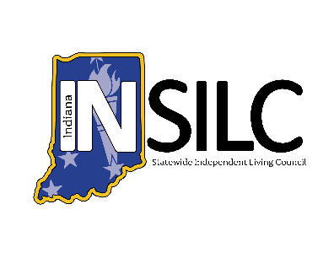
INSILC Public Meeting Posting Schedule

Public meeting information will be posted via website, email blast, and social media at least 30 days prior to the meeting date. Materials may be posted earlier than the 30-day requirement.
A final reminder email and social media post will be published two days prior to the meeting with the complete agenda.
For questions about the public meetings or to request an accommodation to attend, please email Info@IndianaSILC.org.

Public Meeting Date | Website Posting Date | Newsletter Blast Date | Social Media Post Date | Final Email/Social Reminder Date
July 23, 2025 | May 1, 2025 | June 23, 2025 | June 23, 2025 | July 21, 2025
September 10, 2025 | August 11, 2025 | August 11, 2025 | August 11, 2025 | September 8, 2025
December 10, 2025 | November 10, 2025 | November 10, 2025 | November 10, 2025 | December 8, 2025
March 11, 2026 | February 9, 2026 | February 9, 2026 | February 9, 2026 | March 9, 2026
June 10, 2026 | May 11, 2026 | May 11, 2026 | May 11, 2026 | June 8, 2026

